Contents

Table of Figures 4

Introduction 5

Course Information 6

Chapter 1. What is Business Analysis? 7

1.1 The Origins of Business Analysis 7

1.2 The Development of Business Analysis 7

1.3 The Scope of Business Analysis Work 9

1.4 Taking a Holistic Approach 9

1.5 The Role and Responsibilities of a Business Analyst 10

Chapter 2: The Competencies of a Business Analyst 11

2.1 Personal Qualities 11

2.2 Business Knowledge 12

2.3 Professional Techniques 12

2.4 The Development of Competencies 12

Chapter 3: Strategy Analysis 13

3.1 The Context for Strategy 13

3.2 The Definition of Strategy 13

3.3 How is Strategy Developed? 13

3.4 External Environment Analysis 14

3.5 Internal Environment Analysis 14

3.6 SWOT Analysis 16

3.7 Executing Strategy 16

Chapter 4: The Business Analysis Process Model 18

4.1 An Approach to Problem-solving 18

4.2 Stages of the Business Analysis Process Model 19

Chapter 5: Investigation Techniques 20

5.1 Investigation Techniques 20

5.2 Documenting the Current Situation 21

Chapter 6: Stakeholder Analysis and Management 23

6.1 Stakeholder Categories and Identification 24

6.2/6.3 Analysing Stakeholders and Identifying Management Strategies 24

6.4 Managing Stakeholders 25

6.5 Understanding Stakeholder Perspectives 25

6.6 Business Activity Models (BAM) 27

Chapter 7: Modelling Business Processes 29

7.1 Organisational Context 29

7.2 Alternative View of an Organisation 30

7.3 The Organisational View of Business Processes 30

7.4 Value Chain and Value Propositions 31

7.5 Process Models 32

7.6 Analysing the As-is Business Process Model 33

7.7 Improving Business Processes 33

Chapter 8: Defining the Solution 35

8.1 Gap Analysis 35

8.2 Introduction to Business Architecture 36

8.3 Definition of Business Architecture 36

8.4 Business Architecture Techniques 36

Chapter 9. Making a Business and Financial Case 38

9.1 The Business Case in the Project Lifecycle 38

9.2 Identifying Options 38

9.3 Assessing Project Feasibility 39

9.4 Structure of a Business Case 39

9.5 Investment Appraisal 41

Chapter 10. Establishing the Requirements 42

10.1 A Framework for Requirements Engineering 42

10.2 Actors in Requirements Engineering 42

10.3 Requirements Elicitation 42

10.4 Requirements Analysis 43

10.5 Requirements Validation 44

Chapter 11. Documenting and Managing Requirements 45

11.1 The Requirements Document 45

11.2 Requirements Catalogue 46

11.3 Managing Requirements 47

Chapter 12: Modelling Requirements 49

12.1 Modelling System Functions 49

12.2 Modelling System Data 50

Chapter 13. Delivering the Requirements 54

13.1 Delivering the Solution 54

13.2 Context 54

13.3 Delivery Lifecycles 55

Chapter 14. Delivering the Business Solution 58

14.1 BA Role in the Business Change Lifecycle 58

14.2 Design Stage 58

14.3 Implementation Stage 59

14.4 Realisation Stage 60

Table of Figures

Figure 1: The Business Change Lifecycle 8

Figure 2: The Potential Range of the Business Analysis Role 9

Figure 3: Model showing POPIT™ and how it fits into the Business System 10

Figure 4: The Competencies of a Business Analyst 11

Figure 5: Porter's Five Forces Model 14

Figure 6: Boston Box 15

Figure 7: Format of a SWOT 16

Figure 8: The McKinsey 7-S Model 17

Figure 9: The Balanced Business Scorecard 17

Figure 10: A Problem-solving model (after Isaksen and Treffinger, 1985) 18

Figure 11: The Business Analysis Process Model 19

Figure 12: Stakeholder Management at Project Initiation and during Project Execution 23

Figure 13: The Stakeholder Wheel 24

Figure 14: The Stakeholder Power/Interest Grid showing management strategies 24

Figure 15: The 5 stages of SSM 26

Figure 16: Template for a BAM, showing the order for deriving the activity types 28

Figure 17: The vertical nature of the functional view versus the horizontal view of a process 29

Figure 18: Harmon's Alternative View of an Organisation 30

Figure 19: Each Process Receives an Input and Creates an Output 30

Figure 20: Expanding the Process Map into three processes within the business system 31

Figure 21: Michael Porter's Value Chain 31

Figure 22: An example Business Process Model (Swimlane) 33

Figure 23: The Business Case in the Project Lifecycle 38

Figure 24: The Process for Developing Options 39

Figure 25: The Requirements Engineering Framework 42

Figure 26: Example Use Case Diagram showing <<include>> and <<extend>> 50

Figure 27: The Waterfall Model 55

Figure 28: The V-Model 55

Figure 29: The Incremental Lifecycle 56

Figure 30: The SARAH Model 59

Figure 31: The Benefits Realisation Approach 60

Introduction

**Welcome to the Foundation Certificate in Business Analysis.**

Business Analysis covers a very broad range of subject areas and skills.

The Foundation Certificate in Business Analysis expects us to understand this broad range and will test our understanding of a wide range of subject areas.

This course is based on the BCS Business Analysis book, 3rd edition.

Each topic carries a weighting which has been included in the table below.

|  |  |  |
| --- | --- | --- |
| **Chapter** | **Topic** | **Weighting** |
| 1 | What is Business Analysis? | 2.5% |
| 2 | The Competencies of a Business Analyst | 2.5% |
| 3 | Strategy Analysis | 7.5% |
| 4 | The Business Analysis Process Model | 5% |
| 5 | Investigation Techniques | 15% |
| 6 | Stakeholder Analysis and Management | 10% |
| 7 | Modelling Business Processes | 10% |
| 8 | Defining the Solution | 5% |
| 9 | Making a Business and Financial Case | 10% |
| 10 | Establishing the Requirements | 7.5% |
| 11 | Documenting and Managing Requirements | 7.5% |
| 12 | Modelling Requirements | 7.5% |
| 13 | Delivering the Requirements | 5% |
| 14 | Delivering the Business Solution | 5% |

See the BCS website for a copy of the syllabus: <http://certifications.bcs.org/upload/pdf/ba-foundation-syllabus.pdf>

Course Information

This Pre-Course Reading Document

To assist understanding, **BEFORE** the course commences QA expects all delegates to have read this pre-course reading document.

The document consists of extracts from the BCS textbook "Business Analysis" Third Edition, edited by Debra Paul, Donald Yeates and James Cadle. Published 2014[1].

This document also follows the syllabus topics and so is useful for revision as well.

The book will be given to you on day 1 of the course.

The Foundation Exam

The exam has 40 Multiple Choice questions.

This is a one hour, "closed-book" examination where you need to score 26 marks or more to pass.

The Foundation examination will be on the afternoon of the final day and your paper will be independently invigilated and marked by BCS.

BCS Accredited Training Provider

QA as an Accredited Training Provider is responsible for design and creation of the Business Analysis courseware and the delivery of the training.

The BCS International Diploma in Business Analysis

The Foundation Certificate in Business Analysis is an elective Knowledge-based specialism in the Diploma course options.

Attending the Course

**PLEASE REMEMBER TO BRING YOUR PRE-COURSE MATERIALS WITH YOU!**

**We look forward to welcoming you on your Business Analysis course.**

Chapter 1. What is Business Analysis?

1.1 The Origins of Business Analysis

Developments in IT have enabled organisations to facilitate better communications, implement new business models and focus on business operations and management decision-making.

This has shifted the focus towards developing products and services, largely to remain competitive (and profitable) businesses. However, for many years there has been a growing dissatisfaction in business with the support provided by IT and recognition by senior management that IT investment often fails to deliver the required business benefit. Businesses, therefore, need to drive the IT investment through an understanding of how to exploit the opportunities available to them.

Business Analysis is an evolving discipline that seeks to overcome these problems by ensuring that business needs are aligned with implementable business change solutions coupled with demonstrable business benefits.

1.2 The Development of Business Analysis

The Impact of Outsourcing

In an effort to reduce costs, and sometimes due to a lack of IT expertise, many organisations have outsourced their IT operations.

This arrangement has the following advantages:

* Costs are reduced
* No need for in-house expertise
* The supplier has an additional revenue stream

It also however, has a number of disadvantages:

* Communication between the business and suppliers needs to be frequent and controlled to ensure that there is an understanding of the business problem as well as the suitability of a resolution
* Both parties need to understand one another's business
* Requirements often need to be more accurate and robust due to complications with communication

The above has been a catalyst for the development of the business analysis function as organisations recognise the importance of business representation in the development and implementation of IT systems.

Competitive Advantage of Using IT

Organisations have discovered that for IT systems to deliver competitive advantage:

* The needs of the business must drive the development of IT systems
* The implementation of IT systems must be accompanied by the necessary business changes
* The IT requirements must be rigorously and accurately defined

The first two areas required the development of the business analysis role, with the last being covered by the role of the systems analyst.

Successful Business Change

Increasingly, organisations have broadened their view from IT projects to business change programmes.

In addition, the business change lifecycle was developed, and the roles of programme manager and business change manager have been defined.

The business analyst has a role to play in identifying the issues around the problem situation and ensuring that the solution aligns with the needs of the business.

The business change lifecycle, shown below, represents the complete cycle of change and stages within that.

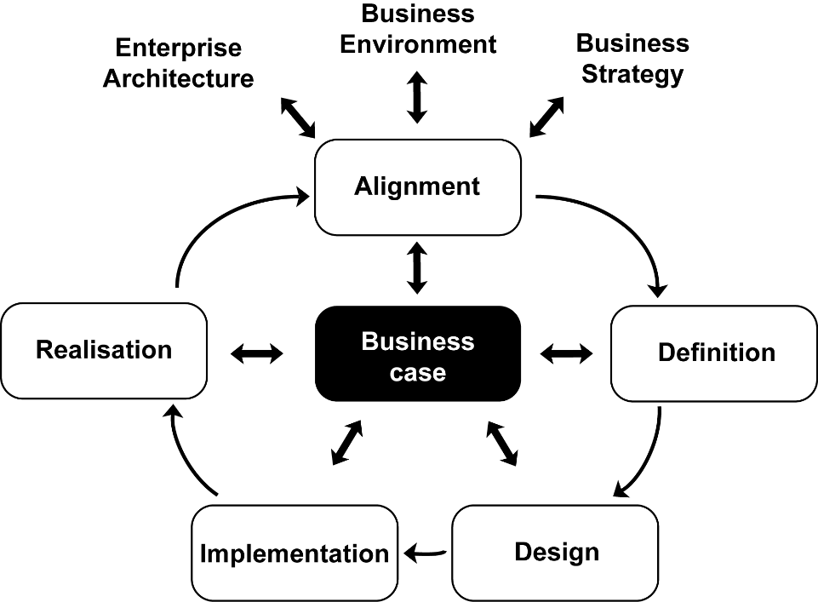Figure 1: The Business Change Lifecycle

We start with **Alignment** and **Definition**; aligning with the needs (and strategy) of the business, the environment and the existing structure of our organisation and defining the problem area, along with requirements.

**Design** and **Implementation** involves the development and testing of the solution and Implementation includes change management and use acceptance testing activities.

**Realisation** is concerned with ensuring that the business change has been successful, or otherwise.

The Importance of the Business Analyst

The business analyst can help identify solutions to business issues and opportunities which are not always provided by IT.

Ensuring that predicted business benefits are achieved is increasingly important in a global economic environment where budgets are limited and organisations cannot afford to waste financial resources.

Business Analysis as Internal Consultants

Many organisations use external consultants because:

* They can be employed to deal with a specific issue on an 'as-needed' basis
* They bring a broader business perspective
* They can provide an objective view of the company

However, the use of consultants is often criticised because of the:

* Lack of accountability
* Absence of any transfer of skills
* Cost

Business analysts argue that they can provide the same services as external consultants and can operate as internal consultants with the following advantages:

* Lower costs
* Speed, as they are knowledgeable about the business domain
* Retention of knowledge within the organisation
* They will have to live with the impact of the actions they recommend

1.3 The Scope of Business Analysis Work

Some business analysts may be required to undertake **strategic analysis** and identify business transformation actions, but most will have a role to play in supporting this activity.

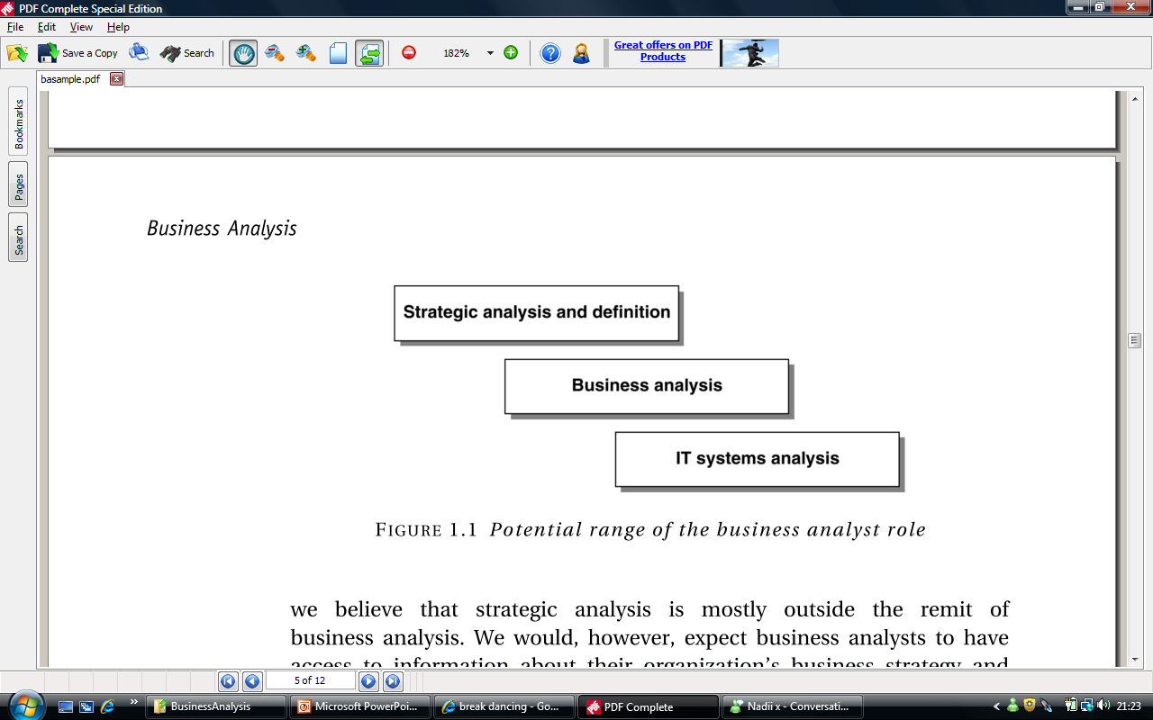Figure 2: The Potential Range of the Business Analysis Role

**IT systems analysts** are responsible for analysing and specifying the IT system requirements in sufficient detail for a system to be built or a software package purchased. However, the **business** **analyst** is responsible for considering a range of business options to address a particular problem of opportunity.

The options may, or may, not include IT. Business Systems Analysts can cover the systems analysis and business analysis roles.

The core **business analysis** role is:

* To investigate a business system where improvements are required
* To recommend actions that would overcome a problem or achieve business benefits
* To make recommendations for business changes supported by a rigorous business case

1.4 Taking a Holistic Approach

When identifying areas for improving a business system, the business analyst must consider all aspects of the operational business system. This is known as taking a holistic approach, which is essential for the business to obtain business benefits.

A useful mnemonic to remember the four views of a business system is POPIT™.

Figure 3: Model showing POPIT™ and how it fits into the Business System

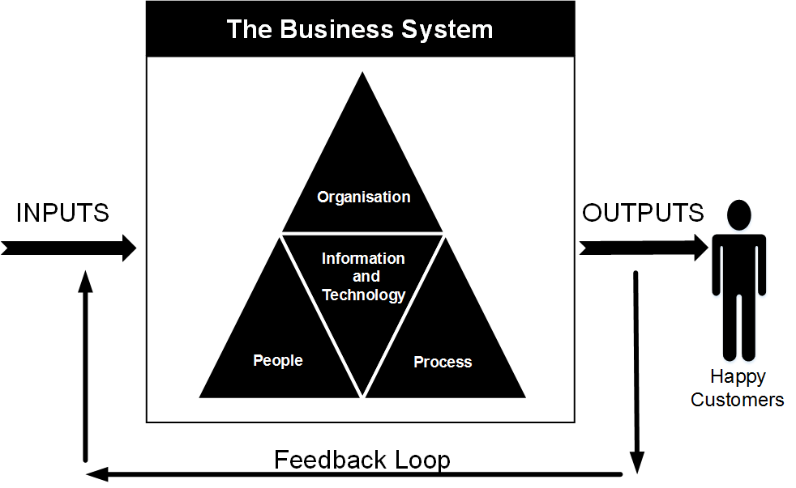

The business analyst may be required to support the implementation of the business change within the business system.

The holistic view offers an effective structure for identifying the range of areas to be considered when planning the implementation.

1.5 The Role and Responsibilities of a Business Analyst

Core responsibilities:

|  |  |
| --- | --- |
| Investigate Business Systems | Evaluate actions |
| Document the business requirements | Elaborate requirements |

BCS defines the core business analyst role as:

*“An advisory role which has the responsibility for investigating and analysing business situations, identifying and evaluating options for improving business systems, elaborating and defining requirements, and ensuring the effective implementation and use of information systems in line with the needs of the business”[2]*

In addition, business analysts in a more senior or specialist role may be involved with:

* Strategy implementation
* Business case production
* Benefits realisation
* Specification of IT requirements

Chapter 2: The Competencies of a  
Business Analyst

Here we will define a competency as something a business analyst needs in order to perform his or her job effectively. See below for the competency groupings.

Figure 4: The Competencies of a Business Analyst

2.1 Personal Qualities

This category relates to the interpersonal skills and characteristics that a business analyst would find useful.

* Communication
* Relationship building
* Influencing
* Team working
* Political awareness
  + Here we are thinking about **internal** politics, the ability to work out what is and is not politically acceptable in an organisation
* Analytical skills and critical thinking
* Attention to detail
* Problem solving
* Leadership
  + Developing a vision, taking ownership of that vision and ensuring actions to achieve that vision are implemented, are leadership characteristics that apply to all types of work, including business analysis
* Self-belief
* Professional development

2.2 Business Knowledge

This set of competencies are related to the range of business knowledge that might be useful for a business analyst.

* Business Finance and the economy
* Business case development*
* Domain knowledge/Subject matter expertise
  + The sector in which your organisation operates, for example, private, public, not-for-profit
* Principles of IT
* Organisation structure and design
* Supplier management – different contractual arrangements which are available:
  + Time and materials
  + Fixed price delivery
  + Risk and reward
* Business Architecture

2.3 Professional Techniques

The range of business analysis activities that could be relevant to your work:

* Project management
* Strategy analysis*
* Stakeholder analysis and management*
* Investigation techniques*
* Requirements engineering*
* Business and data modelling*
* Gap analysis
* Facilitation techniques
* Portfolio management
* Benefits management*
* Agile thinking

Competencies marked above with * are covered in the course.

2.4 The Development of Competencies

A first step is to understand the competencies required of a business analyst in your organisation, considering current and future requirements, then compare them to your own skillset. There are three ways in which business analysts can develop their competencies:

* Training
* Self-study
* Work experience

Your organisation may use a framework such as the Skills Framework for the Information Age (SFIA) – pronounced 'sofia' – the British Computer Society's model. SFIA and SFIA plus include six categories of skills including business change.

SFIAplus provides more detail than SFIA and should be treated as a standard, whereas SFIA may be tailored to an organisation's needs. SFIAplus enables organisations to classify and benchmark their IT skills and to train and develop their teams to meet the defined skill requirements.

Chapter 3: Strategy Analysis

3.1 The Context for Strategy

Strategy has its origins in the military in the sense that it's about 'preparing for battle'. In business terms it's about the direction of the business – where is it headed; the period of time over which the goals are set (usually long-term); how resources are organised to manage the need to be competitive and the environment and external factors that constrain and influence how the business operates.

3.2 The Definition of Strategy

A popular definition is given by Johnson, Scholes and Whittington (2008):

*"Strategy is the direction and scope of an organisation over the long term, which achieves advantage for the organisation through its configuration of resources within a changing environment and to fulfil stakeholder expectations."*

3.3 How is Strategy Developed?

We can identify several starting points:

* Strategy associated with an **entrepreneurial** individual, who is often also the founder. Think Mark Zuckerberg and Richard Branson
* Decentralised and empowered organisations where all managers are encouraged to use the techniques of strategy analysis and be '**intrapreneurial'** or internally entrepreneurial
* Strategies resulting from a **formal planning process**. This is essential for some organisations; especially those for which strategy is truly long-term, for example, Railtrack

We also have to recognise another force in the making of strategy; **politics.** Rather than strategy developed in a rational way, it is developed through the promotion of specific ideas of the most powerful groups. This power comes from:

* **Dependency –** departments are dependent on those departments that have control over the organisation's resources, for example, HR
* **Financial resources –** who controls the funds needed to invest in new ideas, products or services
* **Position –** where the individuals live in the organisational structure
* **Uniqueness –** no other part of the organisation can do what the powerful group does
* **Uncertainty –** groups can cope with the unpredictable effects of the environment

Whichever approach to strategy development we take, it is important to provide a **written** **statement** of our strategy because:

* It provides a focus for the organisation at all levels
* It provides a framework for the allocation of investment and other resources
* It provides a guide to innovation
* It enables appropriate performance measures to be put in place
* It tells the outside world, our stakeholders, about us

3.4 External Environment Analysis

Most organisations face a complex and changing external environment of increasing unpredictability.

There are a number of tools that can help us to analyse the external environment:

PESTLE Analysis

PESTLE analysis provides a framework to examine the external environment and examines the Political, Economic, Sociocultural, Technological, Legal and Environmental factors that may affect the business.

Figure 5: Porter's Five Forces Model

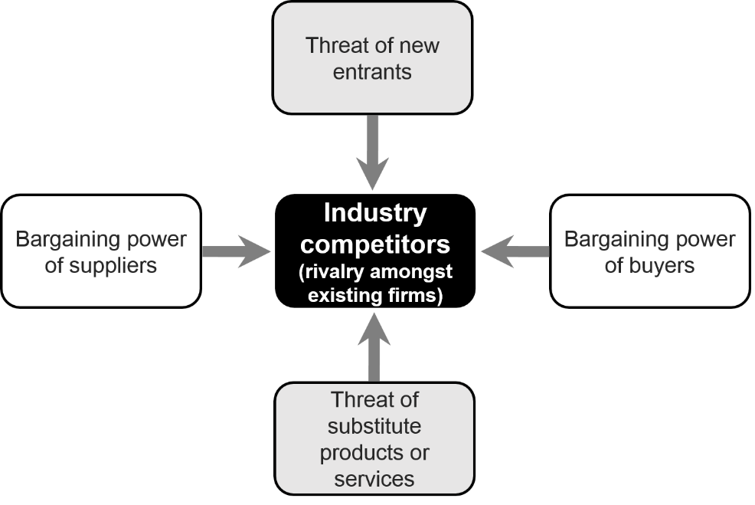Porter's 5 Forces

Michael Porter's five forces model (Porter 1980) is an analysis tool that helps to evaluate an industry's profitability and hence its attractiveness.

The competitive or industry battleground (in the centre), where rivals compete and competitive strategies are developed.

Organisations seek to understand the nature of the competitive environment, and the interplay of the five forces,   
in order to develop strategies   
against the threat they pose.

Scenarios

Scenarios can be used to extend the analysis of the external environment achieved from PESTLE and Porter's 5 forces and consider the impact the different factors may have on the business.

Opportunities and Threats

The external environment creates opportunities and threats and can give an 'outside-in' stimulus to the development of strategy.

Opportunities and threats form components of a SWOT analysis.

3.5 Internal Environment Analysis

Every organisation needs to ask whether it has the capability to change to fit the environment in which it operates.

To understand the organisation's capabilities we will look at two internal analyses: the **Resource Audit** and portfolio analysis using the **Boston Matrix (Boston Matrix)**.

MOST Analysis

But, first we must understand the current business positioning and to do this we use the **MOST** analysis to consider whether they are clearly defined and supported within the organisation.

We can define the MOST terms as follows:

* **Mission –** describes what business the organisation is in, and what it is intending to achieve
* **Objectives –** the goals against which the organisation's achievements can be measured
* **Strategy –** the approach that is going to be taken to achieve the mission and objectives
* **Tactics –** the detailed means by which the strategy will be implemented

The Resource Audit

Reflecting on core competences starts the strategy process from inside the organisation, and so is an 'inside-out' approach based on the belief that competitiveness comes from the ability to create new products and services from a set of core competences.

The **resource audit** can help identify strengths and weaknesses of these competences by examining the **tangible** resources:

* The **physical** resources – for example, buildings, plant, equipment, land
* The **financial** resources that determine the organisation's financial stability
* The **human** resources

And the **intangible** resources:

* The **know-how** of the organisation
* The **reputation** of the organisation

Portfolio Analysis: Boston Box

Many businesses have a diversified range of products and services.

**Portfolio analysis** of a business helps organisations to achieve balance with a mixture of high-growth, profit-maximising, investment-needing and declining products and services. This technique allows us to review the products and services against revenue potential.

A successful product or service starts as a wild cat and goes clockwise round the model until it dies or is revitalised as a new product, service or Business Unit.

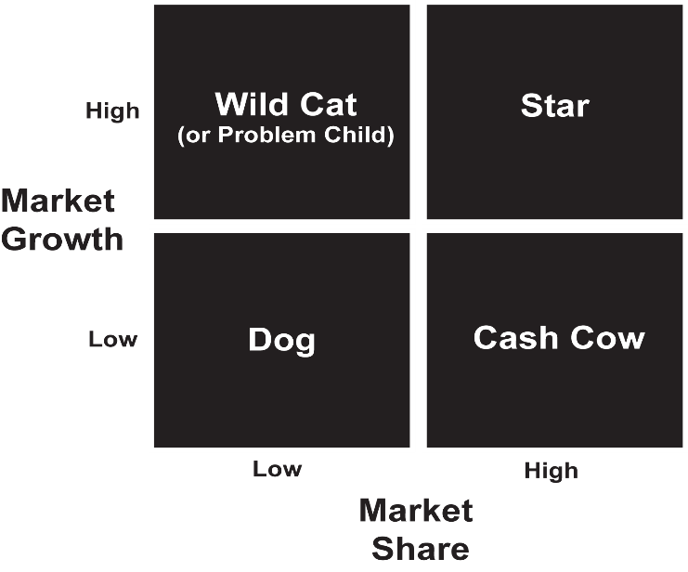

Figure 6: Boston Box

3.6 SWOT Analysis

SWOT (Strengths, Weaknesses, Opportunities and Threats) analysis can be used to pull together the results of an analysis of the external and internal environments.

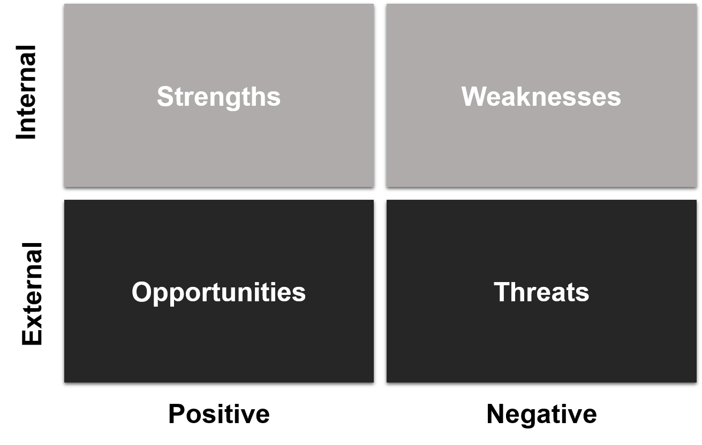

Figure 7: Format of a SWOT

3.7 Executing Strategy

Implementing new strategies implies risk because it involves change.

We need to consider the context for the strategy, the role of the strategic leader and tools to assist strategy implementation **the McKinsey 7-S Model**, the **Balanced Business Scorecard (BBS)** and **Critical Success Factors (CSF) and Key Performance Indicators (KPI).**

First the context:

* **Time –** How quickly does the new strategy need to be implemented?
* **Scope –** How big is the change? Is it incremental or transformational?
* **Capability –** Is the organisation used to change?
* **Readiness –** Is the whole organisation, or part affected, ready for the change?
* **Strategic leader –** Is there a strategic leader?

The strategic leader has a key role in enabling the successful implementation of strategic change. The key characteristics of the strategic leader are that he or she:

* Challenges the status quo
* Establishes and communicates a clear vision of the direction to be taken
* 'Models the way'
* Empowers people to deliver their parts of the strategic change
* Celebrates success

The McKinsey 7-S Model

Figure 8: The McKinsey 7-S Model

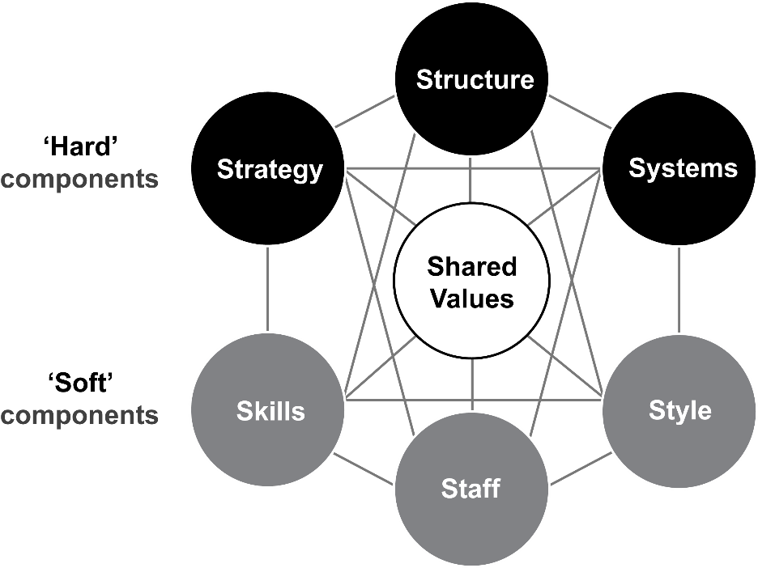This model supposes that all organisations are made up of seven components.

Three are often described as 'hard' components – strategy, structure and systems, and four as 'soft' – shared values, style, staff and skills.

If there is a change in one component, others will be affected.

All seven levers therefore need attention if the implementation is to be successful.

The Balanced Business Scorecard (BBS)

Figure 9: The Balanced Business Scorecard

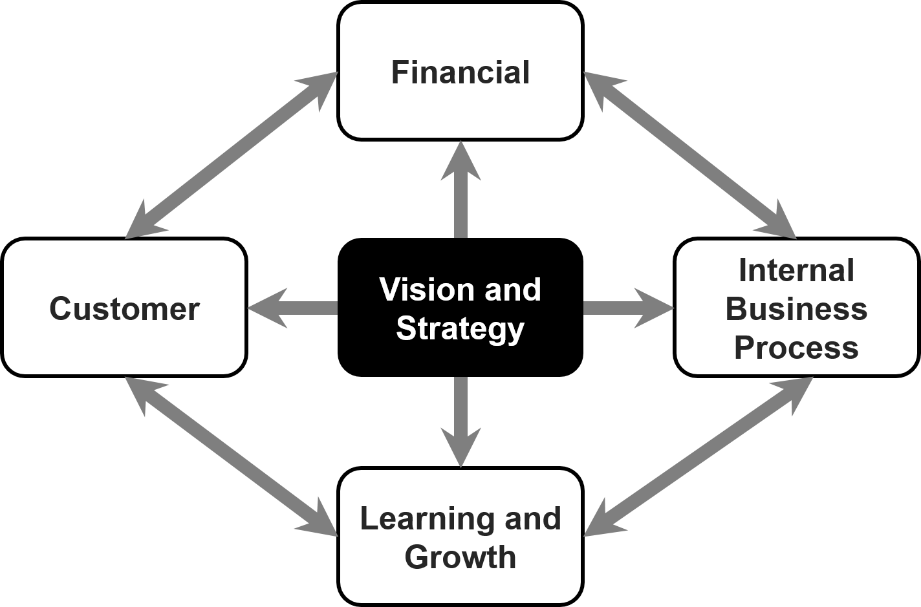This can be thought of as the strategic balance sheet for an organisation since it captures both the financial and non-financial components of a strategy.

When implementing strategy it is essential to identify critical success factors in both financial and non-financial components and use associated key performance indicators to monitor progress in each area towards achieving the strategy and vision.

The acronym CLIF will help you remember the four components of the BBS.

The BBS was developed by Kaplan and Norton (1996).

Critical Success Factors and Key Performance Indicators

The BBS helps to identify two key components which are vital to assessing the performance of the business:

* Critical Success Factors (CSF)
  + The things an organisation must be good at in order to succeed
* Key Performance Indicators (KPI)
  + The things an organisation measures to find out how well it is doing

Chapter 4: The Business Analysis Process Model

The Business Analysis Process model is a framework within which both standard modelling techniques and organisational templates can be used. The framework enables the Business Analyst to determine the most appropriate **tools and techniques** for each situation, and incorporates the best practice principles of requirements engineering.

4.1 An Approach to Problem-solving

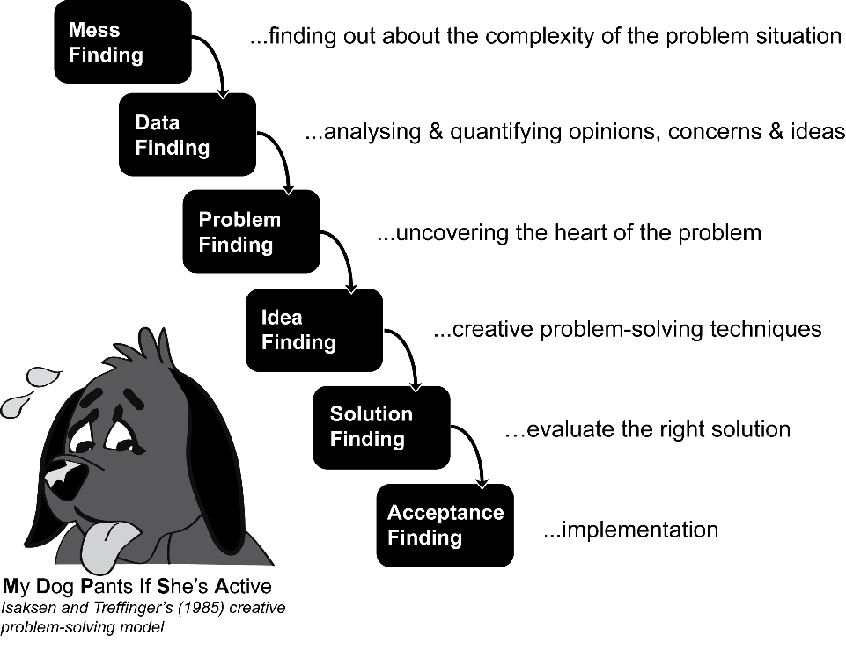Before the BA starts to delve into the solution they need to first understand the problem situation. Isaksen and Treffinger's (1985) creative problem-solving model provides a useful framework for understanding business problems and developing creative solutions. The model emphasises the need to investigate and analyse rather than leap to quick, possibly premature, solutions.

Figure 10: A Problem-solving model (after Isaksen and Treffinger, 1985)

When applied to business analysis the model may be used as follows:

* **Mess finding** – understand the complexity of the problem situation, document with a rich picture or mind map
* **Data finding** – analyse opinions, concerns, knowledge and ideas. Identify where supporting data will help quantify this information
* **Problem finding** – using the work of the two previous stages uncover the heart of the problem

The first three stages are concerned with understanding the problem, the next two stages focus on developing solutions:

* **Idea finding –** use creative problem, solving techniques to generate a wide range of ideas, for example, brainstorming, assumption reversal, random words or pictures
* **Solution finding –** evaluate the ideas that could provide solutions to the problem(s)

The final stage is **Acceptance finding**, which is concerned with managing the implementation of the solution.

4.2 Stages of the Business Analysis Process Model

Figure 11: The Business Analysis Process Model

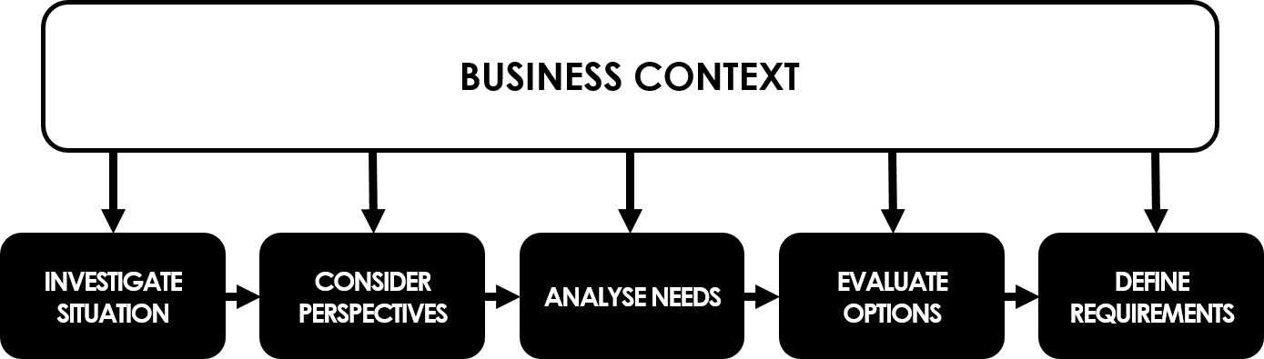

This model sets out the key stages for a business analysis project, with each stage representing the areas that need to be considered. Some projects may require a detailed exploration of all the stages, other projects may focus on a subset of the model, possibly just one stage.

In the course you will be taken through each of the stages, looking at the **objectives**, identifying the **inputs**, the **techniques** used and the **outputs** from the stage. Briefly, the stages are:

* **Investigate** the **situation –** uncover issues and problems in the business
* **Consider** the **perspectives –** analyse stakeholders and consider their perspective of the situation, their view of what the business should be doing
* **Analyse** the **needs –** identify where improvements can be made to the business system by doing a 'gap analysis'
* **Evaluate** the **options –** examine the potential improvements identified so far developing some business options, evaluate them for acceptability and feasibility and produce a Business Case
* **Define** the **requirements –** gather and document the detailed requirements for changes to the business system recommended and signed off from the Business Case

We can extend the Business Analysis Process Model and include delivery of the changes. The business analyst may not necessarily be fully involved in this stage and may act in a support role.

Once the business analysts have analysed the situation, developed options for improvement and defined the requirements to be delivered, it is important to consider how the requirements will be delivered, the changes implemented and the business benefits realised.

We will consider the Objectives, Procedures and Techniques used for each stage in the Business Analysis Process Model during the course.

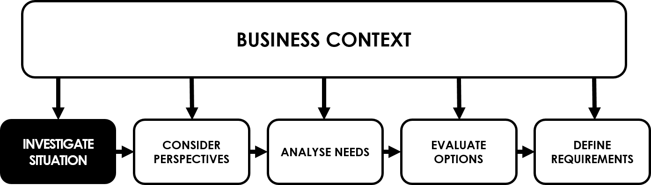Chapter 5: Investigation Techniques

If analysts are working with an unfamiliar client organisation (or division or department) they should spend time gathering background information prior to beginning the investigation stage of the Business Analysis Process model, by studying:

* Company reports
* The company website
* Procedure manuals and documentation
* The organisation chart of the target area of the company

5.1 Investigation Techniques

The techniques can be categorised broadly as **qualitative** – understanding what is needed – and **quantitative** – concerned with volumes and frequencies.

Qualitative approaches

| **Technique** | **Description** | **Tools** |
| --- | --- | --- |
| **Interviews** | Usually one-to-one, confidential | The **STOP** model to explore who to interview |
| **Observation** | * **Formal observation** – watching a specific task being performed * **Protocol analysis** – business staff perform a task and describe each step as they perform it * **Shadowing** – following a business user for one or two days to find out what a job entails * **Ethnographic study** – the analyst spends an extended period, possibly several months, in the target environment | |
| **Workshops** | A structured meeting, ideally lead by an independent facilitator.  A variety of discovery and documentation techniques may be used in a workshop. | Discovery techniques include:   * Round robin * Brainstorming * Brainwriting * Post-it exercise * Stepwise refinement   Documentation could be by:   * Process models to understand the As-Is * Rich pictures (which are a snapshot of the current situation) capture stakeholder concerns and the overall business situation to be considered * Mind maps * Context diagrams * Use case diagrams * Task scenarios |
| **Hothouse Workshop** | A type of workshop focusing on a specific problem, run using Agile or Lean and typically geared towards innovation. Tend to be intense and ‘heated’. | |
| **Focus Groups** | A type of workshop which tends to be concerned with opinions about the current or future business and market research. | |
| **Scenarios** | The business user tells the story of a transaction from trigger to outcome, capture the 'happy-day' scenario first | |
| **Prototyping** | Creating a 'demonstration system' to help clarify vague requirements, may be mock-ups on paper using flipchart sheets, pens and packs of Post-it notes | |

Quantitative Approaches

| **Technique** | **Description** |
| --- | --- |
| **Questionnaires or Surveys** | Useful for a limited amount of information from a large audience, particularly if they are geographically dispersed |
| **Special purpose records** | Business users make a record about a specific issue or task, could be as simple as a five bar gate tally |
| **Activity sampling** | A quantitative form of observation, where the amount of time taken on a range of activities is recorded by the business analyst |
| **Document analysis** | Reviewing completed forms, screen layouts and reports to uncover detailed information about an organisation, process or system |

We will consider the advantages and disadvantages of some of the techniques during the course.

5.2 Documenting the Current Situation

Once we have understood the situation from talking to our stakeholders and analysis of different documentation, we need to document it. The following are useful techniques for documentation and it will largely depend on the context to determine the suitability of the techniques.

Written reports may be suitable but there are also a variety of graphical techniques available.

* **Rich pictures** – a free format representation of the entire business situation
* **Mind maps** – a tool for summarising a lot of information visually, showing connections between ideas and topics

Also useful, but not covered in the syllabus:

* **Business process models** – to understand how a process is carried out a 'swim-lane' diagram or an activity diagram may be drawn
* **Spaghetti maps** – show the movements and interactions of stakeholders when performing particular tasks and processes
* **Fishbone diagrams** –known as Ishikawa or root cause diagrams. Usually incorporates the ‘5-whys’.
* A **business needs log** can be produced once the key causes of the problems have been identified and we can begin to consider how the problem may be addressed, which may lead to some high level business requirements

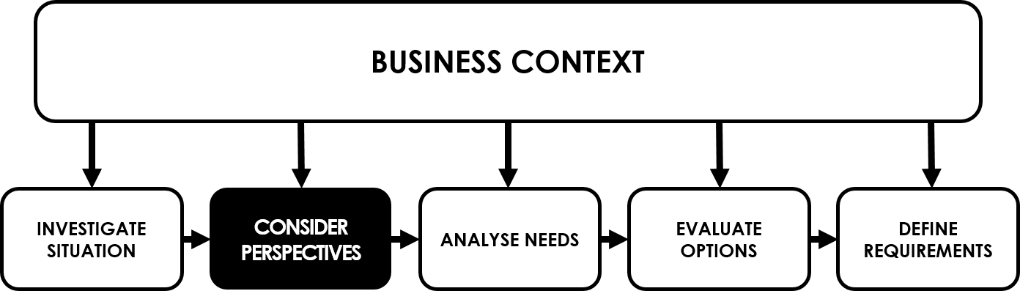Chapter 6: Stakeholder Analysis and Management

Effective stakeholder management is essential for the success of a business analysis project. The main responsibility for stakeholder management may rest with the project manager or perhaps a senior business analyst, but all project team members have a role to play in identifying stakeholders, helping to understand their needs, managing their expectations and monitoring any changes during the project lifecycle.

Stakeholder manager must take place throughout the project lifecycle.

Figure 12: Stakeholder Management at Project Initiation and during Project Execution

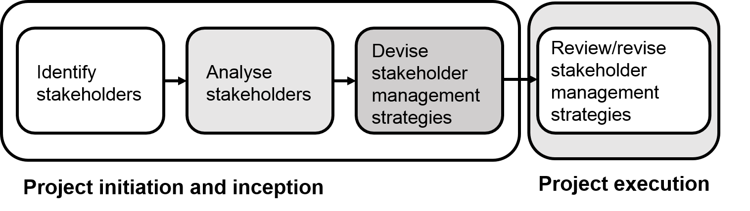

A stakeholder is *anyone who has an interest in, or may be affected by the issue under consideration*.

Stakeholders may be external to an organisation or operate externally to the organisation.

6.1 Stakeholder Categories and Identification

To ensure that the identification of the stakeholders is as complete as possible a workshop may be held with people who are knowledgeable about the organisation and the proposed project.

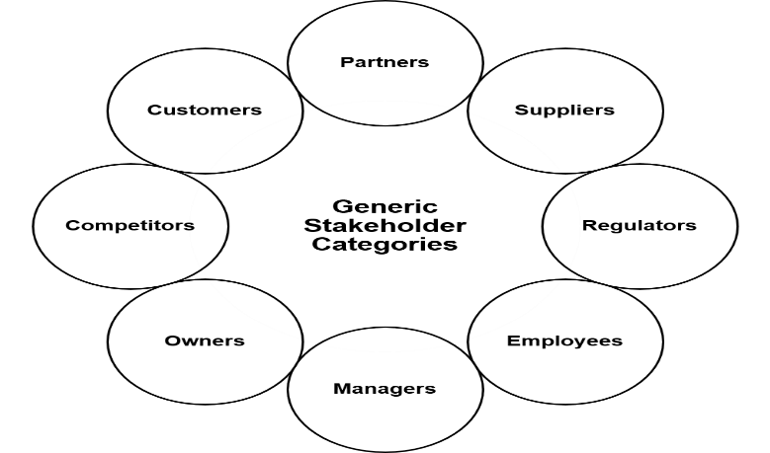Generic stakeholder categories that apply to many projects are shown in the 'Stakeholder Wheel' below:

Figure 13: The Stakeholder Wheel

6.2/6.3 Analysing Stakeholders and Identifying Management Strategies

The next step is to analyse the attitudes towards the project, assess their interest in the project and the amount of power or influence they have, which will determine their ability to support or obstruct it.

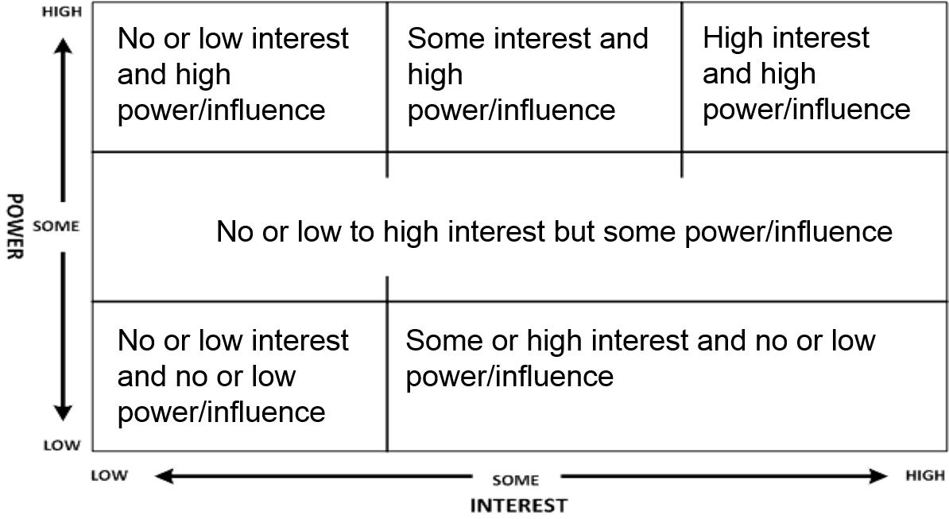The stakeholder analysis may be plotted on a **Power/Interest Grid** and then management strategies can be applied (see figure below):

Figure 14: The Stakeholder Power/Interest Grid showing management strategies

* No interest and no power/influence – **ignore** as regards day-to-day project issues
* Some or high interest but no power/influence – **keep** these stakeholders **informed** during the project and of the reasons for the proposed change
* No, some or high interest and some power/influence – **keep onside** by frequent   
  positive communication
* No interest but high power/influence – **Watch** these stakeholders, they may be senior managers who have no direct interest in the project, but their attitude and interest may change during the project
* Some interest and high power/influence – **Keep** them **satisfied**, their interest may be indirect but they have real power
* High interest and high power influence – these are key stakeholders, they must be kept informed at all stages of the project. They require **constant active management**

6.4 Managing Stakeholders

Stakeholders' positions on the grid may not stay in the same place during the life of the project; their power or interest may change, and our management of them must change accordingly. Therefore, stakeholder analysis must be a continuing activity throughout the project, and even afterwards to find out what the stakeholders thought of the final outcome.

Once stakeholders' initial positions have been plotted, a plan should be drawn up for how to manage them/communicate with them.

Stakeholder Attitudes

Plotting stakeholders' attitudes may be helpful. We may classify attitude as:

* **Champion:** actively works for the success of the project
* **Supporter:** in favour of the project, but not very active in promoting it
* **Neutral:** neither for or against the project
* **Critic:** not in favour of the project but not actively opposed to it
* **Opponent:** works actively to disrupt, impede or derail the project
* **Blocker:** obstructs progress, maybe for reasons outside the project itself

6.5 Understanding Stakeholder Perspectives

Soft Systems Methodology was developed by Peter Checkland and a team at Lancaster University (1981) to deal with the complexities of real-world business systems. The methodology acknowledging that often there is a great deal of uncertainty about what a problem situation actually is and adopts a ‘learning by action’ approach.

The soft systems model is proposed as an alternative to the hard systems thinking approach, which assumes the goals and objectives of business systems are clear.

Checkland and others recognised that business situations are rarely clear-cut, are often 'messier' and that the softer human aspects i.e. stakeholders' thoughts and concerns, must be taken into account for successful business change.

1. 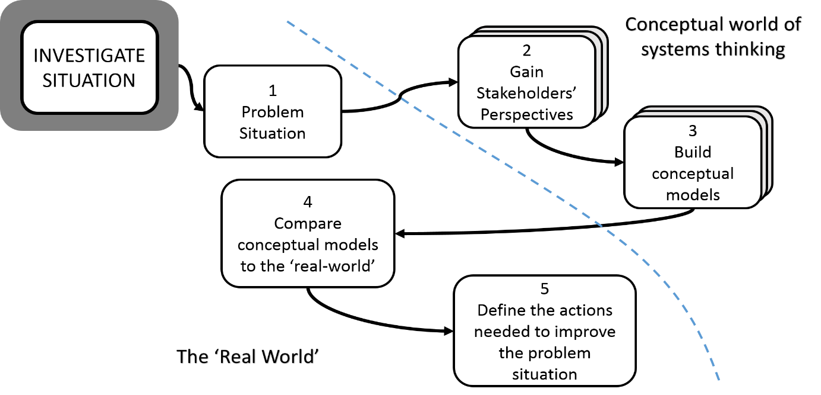**SSM** begins with an investigation into a real world situation of concern (the problem situation) and Checkland proposed we use a 'rich picture' to document it.

Figure 15: The 5 stages of SSM

1. The different 'world view' of each stakeholder is then developed using a **CATWOE** and formalised as a sentence, known by Checkland as a 'root definition', but we prefer the term 'business perspective'.
2. From each business perspective, a model of the stakeholder's desired business system is produced, then the differences between these conceptual models are considered and the models are brought together in one consensus model, which represents the desired future system.
3. This model is then compared to real world models, including the rich picture we produced earlier. By carrying out a gap analysis we can identify feasible, desirable changes that need to be made to the existing business system.
4. This leads us to taking action to improve the problem situation, and could involve changes to the People, Organisation, Processes and Information/Technology (POPIT™).

Analysing the Perspectives/CATWOE

The key stakeholders are asked how they view, from their own perspective, the purpose and objectives of the part of the organisation that is within the scope of the change project.

SSM offers a useful framework for defining and analysing business perspectives, given by the mnemonic **CATWOE.**

The elements of CATWOE are:

**C = customer:** WHO isthe beneficiary (or victim) of the transformation

**A = actor:** WHO arethose responsible for carrying out the business activities within the scope of the view being considered

**T = transformation:** WHAT is the activity at the heart of the system that transforms an input to an output

**W = Weltanschauung or world view:** WHY: an encapsulation of the stakeholder's beliefs about the organisation or business system

**O = owner:** WHO is the person, or group of people, who have the authority to change or even stop the business activities being performed

**E = environment:** HOW will the business system operate, what are the conditions and rules under which the business system operates which are outside the control of the owner, for example, the PESTLE factors

When using CATWOE, it is important to begin by understanding the **Weltanshauung** or world view, since this encapsulates the beliefs that underpin the rest of the CATWOE.

After this, define the **Transformation** and the **Customer**, and then consider the **Actors**, **Owner** and **Environment**.

Checkland's **root definition (or individual business perspective)** is developed as a sentence that ties the CATWOE elements together.

6.6 Business Activity Models (BAM)

A BAM is a 'conceptual model' that shows the business activities we would expect to see in place given the business perspective from which it has been developed.

Ignoring what is currently happening in the business system, we use the BAM or root definition to reveal the activities that comprise the system envisaged by the stakeholder, 'the ought to be'. The principles are:

* Draw one BAM for each business perspective (one per CATWOE developed)
* Bring all the BAMs together in one consensus BAM
* The BAM helps analyse the current business situation against a concept and identifies improvements
* The model is concerned only with WHAT the activities are not WHO carries them out or WHERE they are carried out

Business systems are described using five types of business activity and the dependencies between them. The types of activity, and the order they should be drawn, are:

* **Doing activities –** relate directly to achieving the transformation described in the business perspective, and may be called 'primary task' activities
* **Enabling activities –** ensure resources and facilities needed by the doing activities are obtained and deployed
* **Planning activities –** define the rules regarding the resource required, and performance of these resources is to be measured
* **Monitoring activities –** collect metrics to check the performance of activities against targets set as part of the planning activities
* **Control activities –** act on other activities when monitor activities have identified the need for some action, usually when targets have not been met

Activities are drawn as ellipses – oval shapes - (sometimes as clouds) and the logical dependencies between the activities are shown by an arrow.

Figure 16: Template for a BAM, showing the order for deriving the activity types

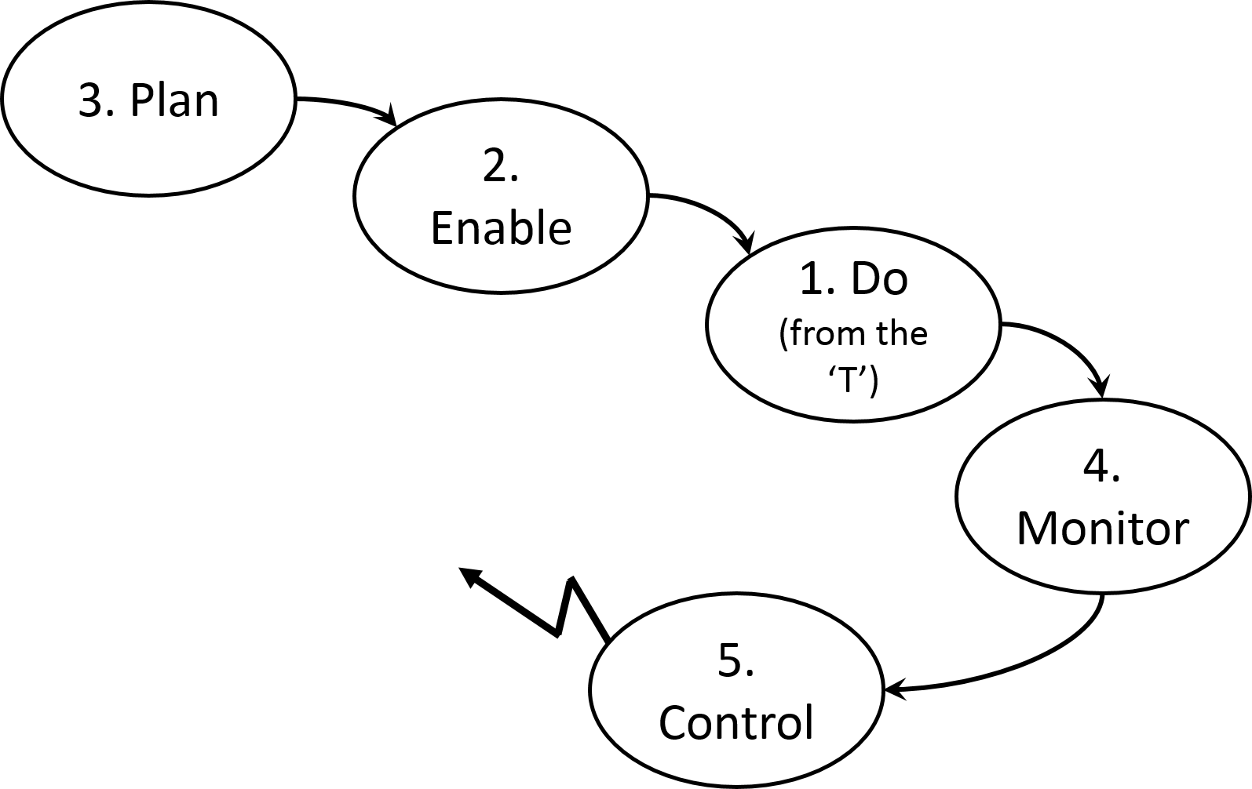

Developing a Consensus Model

The BAMs produced up to this point have each been derived from an individual perspective from a key stakeholder. By merging these models, to take account of all the stakeholder perspectives, we can produce a **consensus model. A consensus model is:**

* A model of what the system **should** look like and what it **should** be doing
* Provides a basis for considering what **opportunities** exist for improvement
* Can be further expanded to consider how the activities are or **should** be carried out

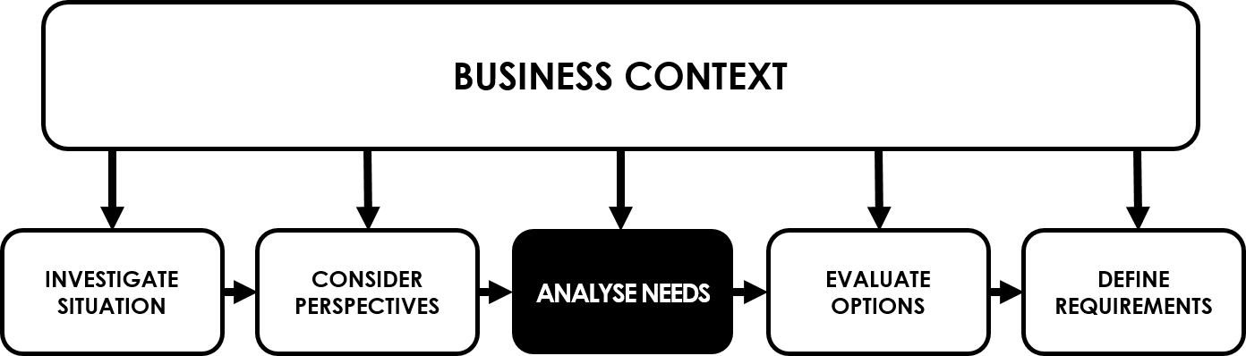Chapter 7: Modelling Business Processes

The business processes are the means by which an organisation carries out its internal operations and delivers products and services to its customers.

We tend to model business processes for communication purposes, either to understand them better or to inform others about what a process involves.

We will look at techniques for modelling business processes, covering both the organisational view of process modelling and the more details business process models.

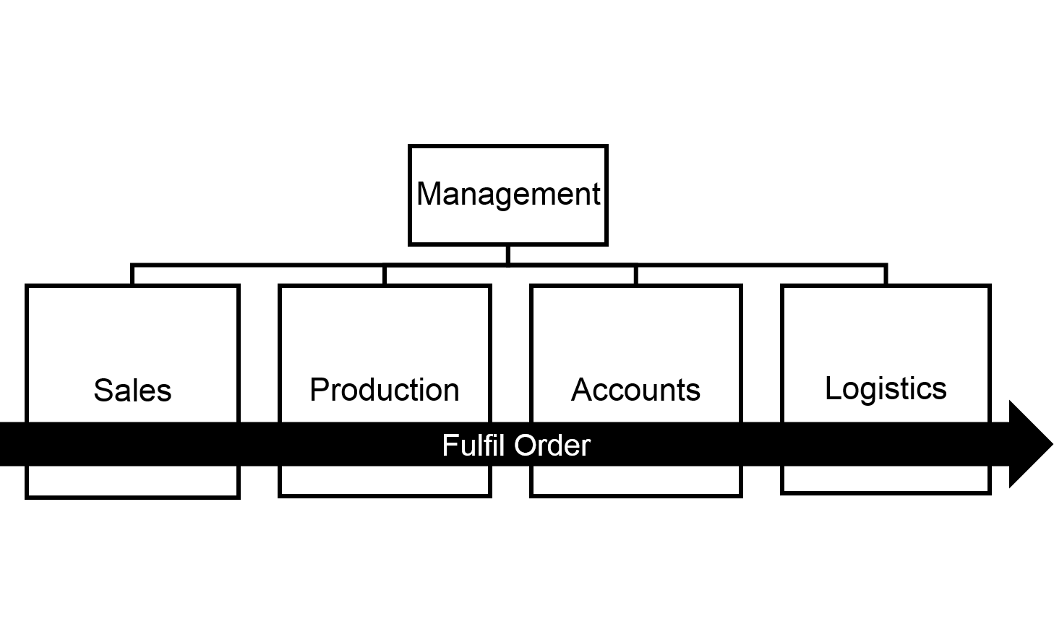7.1 Organisational Context

The traditional view of a business is based on the specialist functional areas such as sales, accounts and operations.

Figure 17: The vertical nature of the functional view versus the horizontal view of a process

The functional view is useful for internal management and staff to see how the organisation is structured and where they fit in, but this view is internally oriented, which is of no interest to the organisation's customers. This view is also 'static', since it does not show what the business does over time to respond to an event such as a customer request for a product or service. This is in contrast to the process view which emphasises the need for cooperation between all the participants to achieve the desired level of customer service.

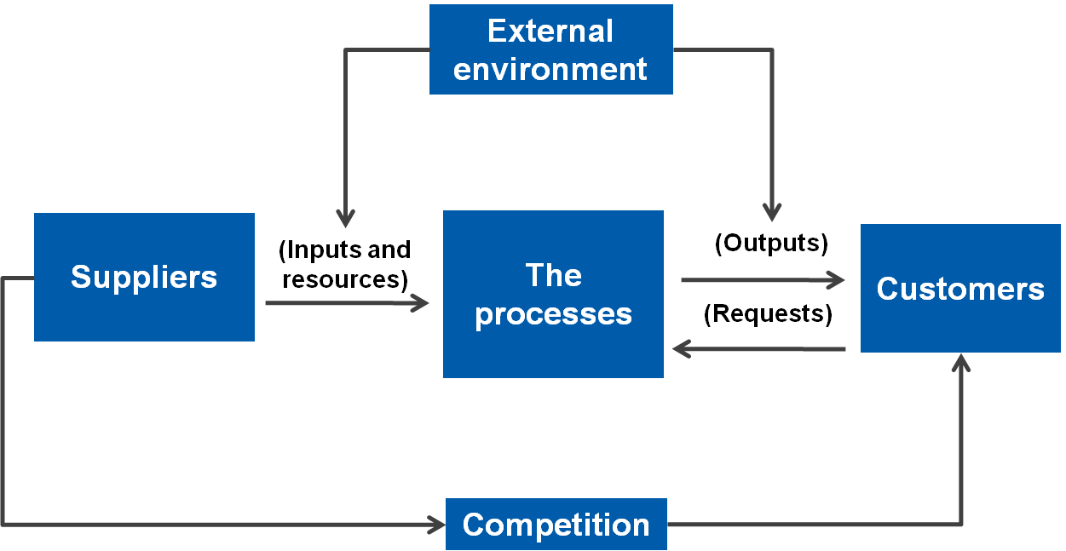7.2 Alternative View of an Organisation

Paul Harmon (2007) offers an alternative view.

Figure 18: Harmon's Alternative View of an Organisation

His organisation model represents both the internal processes and the external world, it is developed in two stages: first the external forces that influence the organisation are considered and then the internal business process is analysed.

7.3 The Organisational View of Business Processes

Once we have understood the circumstances in which the business operates, we can focus on what the business does when reacting to the external environment.

Process Map

What are the internal business processes? Starting with a high-level view of processes that operate across the business, we need to show the end-to end set of processes that convert the inputs from suppliers to the outputs for the customers. This high-level view may be shown:

Figure 19: Each Process Receives an Input and Creates an Output

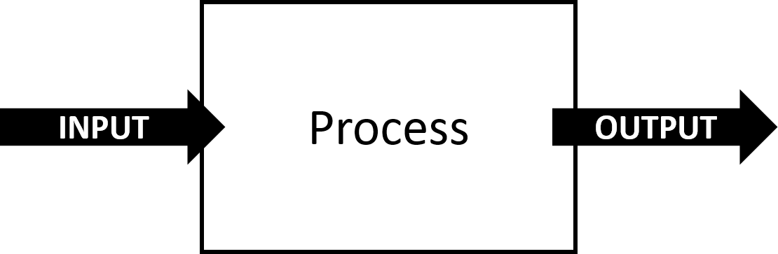

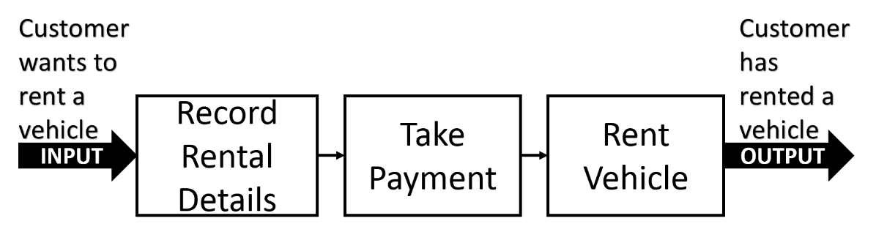To start to build a business process model we take this high-level view and break the process down into a series of related processes, which can be shown on an outline process map:

Figure 20: Expanding the Process Map into three processes within the business system

The next level down from a process map is a Business Process Model. Business process models show a more detailed view of the processes than a process map.

7.4 Value Chain and Value Propositions

Value Chain

A complementary approach to building a process map is to explore the products and consider what processes are required to deliver them.

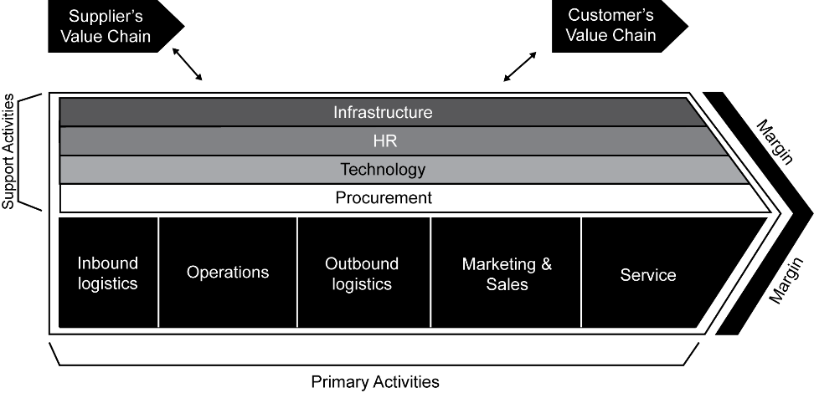Michael Porter's value chain provides a means of analysing the activities performed by an organisation. It identifies the primary and support activities that will be required to deliver value to the organisation's customer and potentially differentiate the organisation from its competitors.

Figure 21: Michael Porter's Value Chain

Value Propositions

A value proposition is a definition of an organisation's product or service that will demonstrate to customers that we understand and can satisfy their needs. Of course it assumes that we understand the customers who purchase our products and services in the first place!

Kaplan and Norton have identified the main attributes that make up a successful proposition: image, reputation and the product or service attributes. The attributes are:

* Functionality – what the product does
* Price
* Quality – how well the product performs
* Choice – do we provide a standard product or service, or can it be tailored to meet the customer's needs.
* Availability or timing – how quickly can we respond to customer requests

7.5 Process Models

Business processes are triggered by business events. Events can be categorised into the following:

* **Internal Event** – originate from within the business system and can be controlled within the system too. They generally relate to decision making as part of the day to day business, for example deciding to hold a flash sale for 24 hours online
* **External Event** – these business events occur outside the business system and the business will have no control over them. The business may be able to influence them through a promotional email for example. If a customer receiving the email decides to purchase something in the sale, they would initiate the process ‘Take Order’
* **Time-based or Scheduled Event** – these events occur at a regular point in time or frequency. For example, a weekly report on sales

A business process is triggered by a business event and includes five components:

* The tasks that make up the process
* The process flow
* The decision points
* The actors that carry out the tasks
* The outcome of the business process

There is no universally agreed set of terms in business process modelling. The following conventions are adopted here:

* **Process** refers to a set of activities starting with a triggering event and ending with some output being delivered
* **Task** refers to an activity within the process carried out by an actor
* **Step** refers to the activities carried out within a task

Developing the business process model

There are many standards for modelling business. Two of the most popular are the UML activity diagram technique (example below) and the Business Process Modelling Notation (BMPN).

To build a business process model, first identify who takes part in the process: the 'actors'. An actor may be an individual, a group, an organisation or an IT system. Each actor is shown in a separate partition or 'swimlane' and arrows are used to show the flow of work between the tasks and the swimlanes.

The flow of work from one actor to another is known as a 'handoff'.

The customer swimlane is normally placed at the top and the action on the model goes from left to right on a horizontal layout, following the time axis, and from top to bottom as different actors are involved in the process.

Tasks should be labelled in a verb-noun format and where possible use specific verbs, avoiding words such as 'manage' or handle'.

Figure 22: An example Business Process Model (Swimlane)

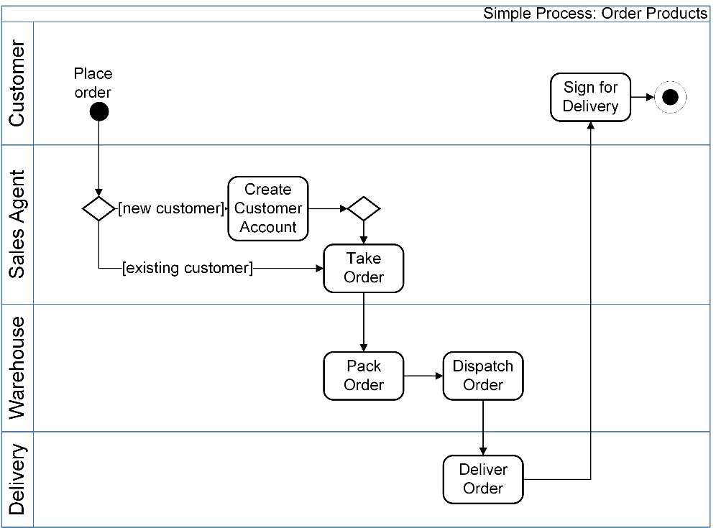

7.6 Analysing the As-is Business Process Model

Analysing the business process model helps us to identify problems with the existing process before producing a replacement process. 'Handoffs' are a frequent source of problems in a business process because they can cause delays, errors and bottlenecks to occur. Look for piecemeal modifications which have been made to parts of the process, without considering the process as a whole, causing inefficiencies and inconsistencies. These problems arise over time and may include:

* Duplication of work
* Lack of standardisation
* Inconsistent measurement or control

7.7 Improving Business Processes

By removing problems identified in the 'as is' process and challenging assumptions upon which the current process was built, we can improve the process and begin to understand what the ‘to-be’ looks like. The approaches to take include:

* Look at the business rules
* Simplify the process
* Remove bottlenecks
* Change the sequence of tasks
* Redefine the process boundaries
* Automate the processing
* Redesign the process

Chapter 8: Defining the Solution

8.1 Gap Analysis

Gap analysis can be used to compare the conceptual views of a business situation against the current as-is situation and identify the differences between them.

The differences give us the basis for defining the actions required to improve the business system. The BAM is one way that we can understand where the gaps exist.

Of course we shouldn't just rely on the BAMs to give us an idea of the required actions – we can also use as-is analysis using the results of our discussions with stakeholders, analysis of process models etc.

These two different views are both very useful and can be used to complement one another in the investigation of the system.

Identifying Areas of Concern

Areas of concern can be identified from the prior analysis of the conceptual vs. the as-is states of the system. We can then prioritise these concerns and assess their impact against the needs of the business.

Framework for Gap Analysis

The POPIT™ model and McKinsey’s 7-S model are useful tools for furthering the analysis completed thus far.

We can consider the following areas in more detail:

**Processes**

* Comparison of the ‘as-is’ vs. the ‘to-be’ and consideration of the impacts to how the business will respond to process changes.

**Information and Technology**

* How will IT be used in the ‘to-be’? Will there be a need for additional process support?
* Are there any issues with access to the IT systems? For example if there is a new centralised system, will provision be made for access by all? Will training be given?
* Does everything work with the Enterprise Architecture? Will new or updated systems be integrated and operable? This could be as simple as having a standard for data file formats so that all systems can use another system’s data

**Organisation**

* McKinsey’s 7-S can be used here

**People**

* How are we planning to deploy the changes? What impacts will be felt by the people using the system on a daily basis?
* Are there any new or updated skills required? How will training be managed?
* Are there any recruitment requirements?
* How will staff be developed?
* How will staff be motivated before, during and after the change has been implemented?

Formulating Options

Once we have an idea of the changes needed and the impacts on all of the POPIT areas, we can begin to look to the options for the change. This stage should always keep the POPIT elements at the forefront of the options analysis so as not to lose the holistic viewpoint.

8.2 Introduction to Business Architecture

A Business Architecture provides:

* Formal definition of the architecture of the business
* Helps align business change proposal
* Provides the **holistic** **blueprint** of business areas
* Shows the interfaces, potential impacts and capabilities to deliver value
* Can facilitate scenarios to determine:
  + Alignment
  + Impacts of change
* Provides a bridge between the defined strategy and execution of strategy

8.3 Definition of Business Architecture

“*A blueprint of the enterprise that provides a common understanding of the organisation that can be used to align strategic objectives and tactical demands*"

The Business Architecture Guild (2014)

8.4 Business Architecture Techniques

There are two techniques that form the basis of defining an effective (and usable) Business Architecture:

**Capability model**

* High level representation of what the organisation needs to do to deliver value to the customer
* Capability = ability to achieve an outcome
* Modelled as layers:
  + Strategic
  + Core or customer facing (value-add)
  + Supporting

**Value Stream Analysis**

*“An end-to-end collection of linear stages that create an outcome of value to a specified customer group”*

* Could be the business customer or an internal customer of whatever value stream is being documented
* Used to identify, map and analyse the value exchange

Chapter 9. Making a Business and Financial Case

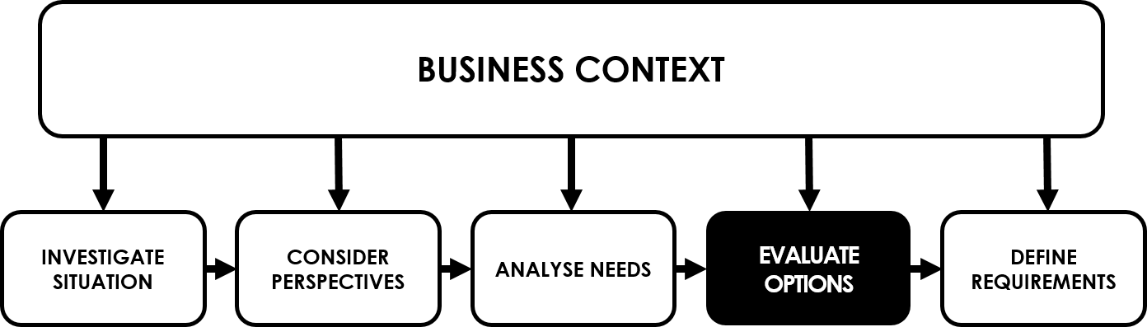

9.1 The Business Case in the Project Lifecycle

A business case is a living document. It should be revised as the project progresses and more is discovered about the proposed solution and the costs and benefits of introducing it.

Between each of the stages of the lifecycle shown there are "decision gates", indicated by the dashed lines. Here the project should pass certain tests before being allowed to proceed to the next stage.

Figure 23: The Business Case in the Project Lifecycle

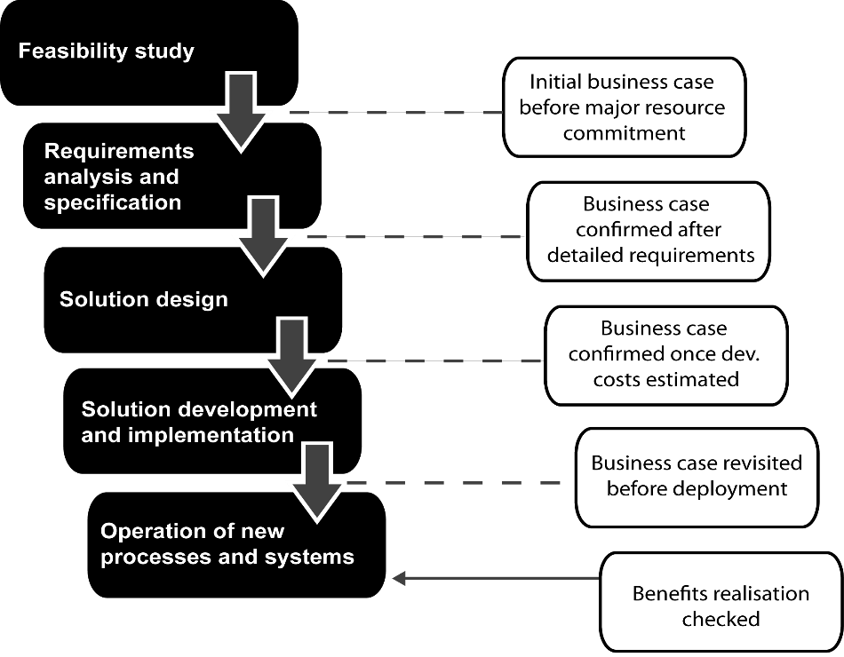9.2 Identifying Options

First we explore two kinds of options:

* **business option,** explore **what** the proposed solution is intended to achievein business terms
* **technical options,** consider **how** the solution is to be implemented often through the use of IT

A process for developing options is shown below:

Figure 24: The Process for Developing Options

Ideally, the shortlist of options should be reduced to three or four, one of which should be maintaining the 'status quo', the 'do nothing' option.

By evaluating the feasibility of the options, some ideas can be rejected. The criteria for assessing feasibility are shown below.

9.3 Assessing Project Feasibility

There are three broad areas to consider: **business**, **technical** and **financial** feasibility.

Options are eliminated that are not feasible under the headings above. Another tool that can be used in assessing feasibility is a PESTLE analysis.

Finally, a force-field analysis (Lewin) can be used to consider the forces inside and outside the organisation that will support adoption of the proposal and those that will oppose it. We need to be sure that the positive forces outweigh the negative.

9.4 Structure of a Business Case

Most business cases have a similar structure and content. They typically include the following elements:

* Introduction
* Management summary
* Description of current situation
* Options considered
* Analysis of costs and benefits
  + Categories
  + Investment appraisal
  + Timescales
* Impact assessment
* Risk assessment
* Recommendations
* Appendices, with supporting information

Categories of Costs and Benefits

The analysis of costs and benefits must reflect the fact that costs and benefits are incurred or enjoyed either immediately or in the longer term. They are also tangible, which means that a credible – usually monetary – value can be placed on them, or intangible, where this is not the case.

In some organisations, the managers will not consider intangible benefits in the business case, whereas in other organisations projects will go ahead where the only benefits are intangible. The tangible costs and benefits are those for which we have a specific basis for measurement, usually financial. For the benefits we would need to have taken a measurement before the project starts so that we have a basis for comparison.

* Tangible 'one-off' costs may occur for example, from new hardware, software packages, user training and data migration (often known as CAPEX – Capital Expenditure).
* Tangible 'ongoing' costs may occur for example, from hardware maintenance and software support/licences (often known as OPEX – Operational Expenditure)
* Tangible benefits may occur from staff savings, improved efficiencies, reduced inventory

Most costs will be tangible, but we must not overlook the ones it is hard to measure.

* Intangible costs could be costs incurred from recruitment for example
* Intangible benefits could be improvements to customer satisfaction and better management information

Risk Assessment

All change involves risk. The business case must identify the potential risks for each option, and suitable countermeasures. For the principle risks record the following:

* **Description –** cause of the risk and its impact
* **Impact assessment –** assess the scale of the damage ideally using quantitative measures
* **Probability –** likelihood of occurrence of risk, for example, low, medium, high
* **Countermeasures –** how to reduce the probability of the event occurring or lessen its impact
* **Ownership** – decide for each risk who, usually from the business area, is responsible for the countermeasures

Impact Assessment

For each of the options in the business case, we need to consider any impacts that there might be on the organisation. Examples of such impacts include:

* Organisation structure
* Interdepartmental relations
* Working practices
* Management style
* Recruitment policy
* Appraisal and promotion criteria
* Supplier relations

The business case must make clear to the decision-makers what changes will have to be made in order to achieve the benefits, and the costs these changes will incur.

9.5 Investment Appraisal

The financial aspects collected from the tangible costs and benefits are used to assess whether and when the project will pay for itself.

Payback

The simplest measure is the **payback** calculation, which is a cash-flow forecast for the project. Payback calculations are a reasonable forecast when interest rates and inflation are low. However, they do not take account of the 'time value of money'.

Discounted Cash Flow (DCF) and Net Present Value (NPV)

A method that does take account of the time value of money is known as **discounted cash flow (DCF).** This discount factor takes account of likely money-market interest rate changes over the duration of the project.

This leads to a **net present value (NPV)** for the project, which means that all of the cash flows in years after the current one are adjusted to today's valueof money by applying a discount factor.

Internal Rate of Return

Another measure that may be used is the **internal rate of return (IRR).**

This calculation assesses what sort of return on investment is represented by the project in terms of a single percentage figure. The IRR is calculated by asking the question: what discount rate would we have to use to get a net present value of zero after five years (or whatever period the organisation mandates should be used for the calculation)? This can be a bit trial and error as the goal is to get an NPV of zero.

However, IRR does not take account of the overall size of the project. For that reason, most accounting textbooks agree that DCF/NPV is the best method of assessing the value of an investment.

Chapter 10. Establishing the Requirements

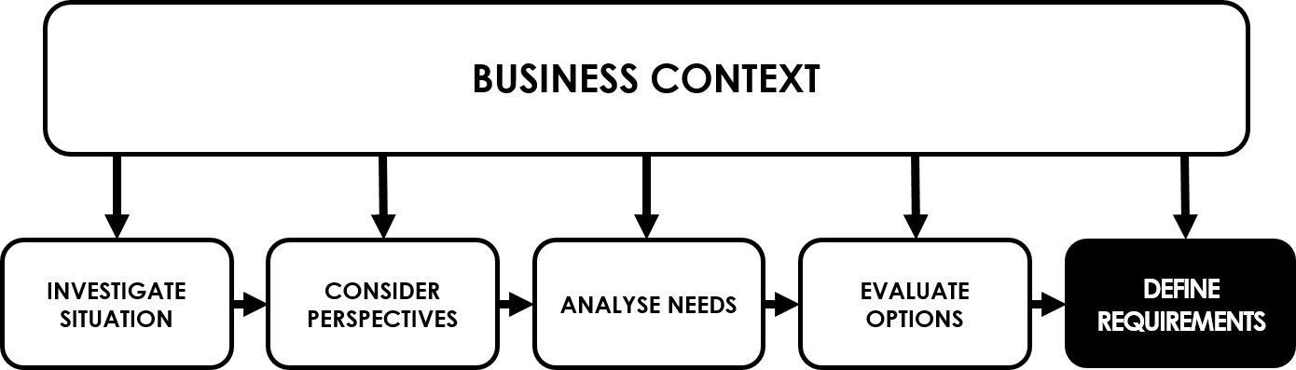

10.1 A Framework for Requirements Engineering

Figure 25: The Requirements Engineering Framework

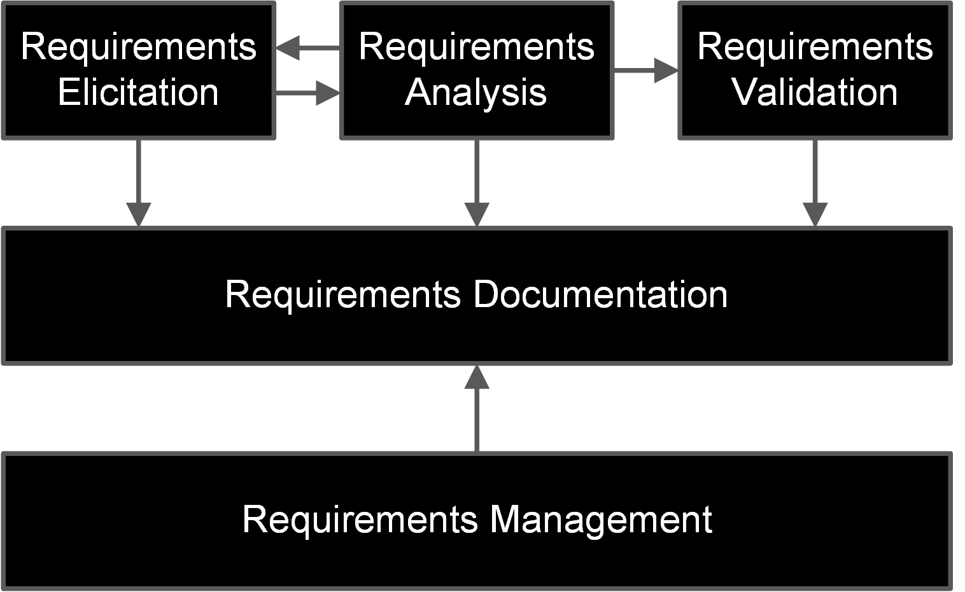

10.2 Actors in Requirements Engineering

Alongside the project team there are also business stakeholders with whom we may need to talk during the requirements process. These stakeholders should include the project sponsor but may also include people who have knowledge about the business area being investigated.

10.3 Requirements Elicitation

This is concerned with gathering information and requirements from the business stakeholders.

The business user will be asked, by means of an interview or a workshop or some other fact finding technique, to tell the business analyst what they know about their job.

Usually, you will be given lots of **explicit knowledge; knowledge of procedures and data*,*** the things that they can easily remember.

What is difficult for people to recall or share is the **tacit knowledge** that is can be a consequence of performing a task frequently and intuitively.

Tacit knowledge can cover the following areas:

* **Skills** **–** explaining how to carry out actions by using words alone is very difficult and sometimes people forget the detailed steps
* **Taken-for-granted information –** very difficult to ask about things you don't know that you don't know!
* **Front story/back story –** you can be told what the standard approved process is but this might not be how they actually do their job. There might be 'work arounds' in place that they don't want to admit
* **Conceptualising requirements** **–** trying to imagine how the system will work in practice can be difficult; various techniques will help with visualisation
* **Gestures or cultural nuances –** cultural differences (such as something as simple as a gesture) mean that what one group might consider normal practice, another group might not understand
* **Intuitive understanding, usually born of considerable experience –** very difficult to articulate but, over time, people just 'know' what to do. If asked to describe how or why they did something they might not be able to describe the steps

Types of tacit and explicit knowledge

|  |  |  |
| --- | --- | --- |
|  | **Tacit** | **Explicit** |
| Individual | Skills, values, taken-for-granted knowledge, intuitiveness | Task definitions, job descriptions, targets, volumes and frequencies |
| Corporate | Norms, back story, culture, communities of practice, organisation history | Procedures, style guides, processes, knowledge sharing repositories, manuals, company reports. |

Requirements Elicitation Techniques

Tacit knowledge must be extracted and documented. We can do this through following AERO:

* Become an **Apprentice** by shadowing or protocol analysis
* Scenario role-playing and prototyping can **Enact** a particular process
* Tell a story or build a scenario and **Recount** what is happening
* Do some observation and **Observe** what actually happens

As we gather the requirements, we will need an organised way to hold all the information. This is covered in **building a requirements list.** Eventually **an organised requirements catalogue** will be produced. The requirements list begins with a high level list of concerns and areas to investigate (it might start as the Business Needs Log) which then evolves into a detailed list and may be presented as a catalogue, spreadsheet or perhaps even entered into a specific Requirements Tool (CASE – Computer-aided Software Engineering, or CARE – Computer-aided Requirements Engineering tool).

10.4 Requirements Analysis

Requirements analysis is concerned with ensuring that all of the requirements identified ensuring the requirements elicitation stage have been developed into clear, well-organised requirements. This stage requires a logical approach as the analyst may be dealing with hundreds of requirements.

We can use the following techniques to analyse our requirements:

Categorisation

* General (business)
* Technical
* Functional
* Non-functional

These types of requirements are described in more detail in the following chapter.

Modelling

We can also model the requirements using data modelling techniques.

Filtering

Applying filters then help us to refine our requirements even further. Filters such as those in the following list can be used:

* Overlapping, duplicate, conflicting
* Multiple
* Necessity and feasibility
* Solution
* Confirm quality
* We can also check that our requirements are SMART

10.5 Requirements Validation

Once our requirements are analysed and well-formed we can then get them validated with our stakeholders using a review group. This groups should include the key business and project representatives.

The review should leave us with one of three key outcomes with regards to the status of the requirements in general:

* 'Signed off' (baselined)
* Some amendments, sign off by chairperson
* Significant rework, review again

Chapter 11. Documenting and Managing Requirements



There are many reasons for needing good documentation:

1. It enables communication within the project team and provides a basis for ensuring that all of the related requirements are consistent with each
2. It provides a firm **basis for validating** the requirements by stakeholders
3. Any further work to **develop and test the business solution** will use the documentation as **input** to these activities

11.1 The Requirements Document

Structure

The document needs to be clearly laid out and should, wherever possible, follow a standard template to ensure nothing is forgotten.

Content of a Requirements Document

* Introduction and background – business situation and drivers for the project
* Business Process Models – 'to be' process and optionally the 'as is' process
* Function model – context or use case diagram of the proposed software solution
* Data model – as appropriate to the solution (ERD or CLASS diagram)
* Requirements catalogue – developed from requirements list (chapter 9)
* Glossary of terms

11.2 Requirements Catalogue

Types of Requirement

|  |  |
| --- | --- |
| **Business: General** | **Solution: Functional** |
| * **Business constraints**   + Budget, timescale, resources etc. * **Business policies**   + Standards, business rules * **Legal**   + Legislative and regulatory constraints * **Branding**   + Image, style guide * **Cultural**   + Vision, approach, management style etc. * **Language**   + If operating across international boundaries | * **Data entry**   + Gathering and recording data * **Data maintenance**   + Changes to data, including data deletion * **Procedural**   + Implementation of business rules * **Retrieval**   + Reporting, responding to enquiries |
| **Business: Technical** | **Solution: Non-functional Requirements** |
| * **Hardware**   + IT and other hardware * **Software**   + Operating systems, package applications, networking, communications etc. * **Interoperability**   + Standards for communicating between systems and devices * **Internet**   + Policies on Internet use and web services | * **Performance**   + Speed of processing transactions * **Security**   + Security levels for protection of data * **Access**   + Permissions, who has access to which functionality and how * **Backup and recovery**   + Protection against loss of data * **Archiving & retention**   + Duration, methods, eventual deletion * **Maintainability**   + Includes servicing, problem detection and correction * **Availability**   + Timeframe for availability of functionality * **Usability**   + Ease of learning, ease of use * **Capacity**   + Data volumes, transaction volumes, user volumes * **Accessibility**   + Usability: enabling access for all |

Hierarchy of Requirements

* Requirements are related to one another
* Should also be related to the organisation’s values, strategy and objectives
* Feasibility, and therefore prioritisation
* Also helps assess timescales and necessity of a requirement

Documenting a Requirement

The requirement list created in chapter 10 is further developed to become the complete requirements catalogue using, where possible, a standard template or possibly a software tool for the purpose.

Contents could include:

1. Unique **requirement identifier** for each requirement to aid traceability
2. Requirement name
3. Requirement description
4. Source
5. Owner
6. Author
7. Type of requirement
8. Priority
   1. M – Must have. Mandatory
   2. S – Should have. Mandatory but can wait until the 2nd increment
   3. C – Could have if time and budget allow
   4. W – Won't have this time/Want to have
9. Business area
10. Stakeholders
11. Associated non-functional requirement
12. Acceptance criteria
13. Related requirements
14. Related documents
15. Comments
16. Rationale
17. Resolution
18. Version history

11.3 Managing Requirements

The elements of the requirements management lifecycle are:

| **Requirements identification** | **A unique ID** |
| --- | --- |
| Cross-referencing | How requirements are related and facilitate traceability. |
| Origin and ownership | The source of this requirement and the future business owner who will be responsible for using it. |
| Configuration management | Configuration management is all about controlling changes within a project and protecting requirements from unauthorised change. |
| Configuration management in Agile | Baselining becomes key to control the changes within the Agile project |
| Software support | Where and how the requirements will be managed, a software tool would be useful. |
| Change control | * Documenting the proposed change (a change request) * Consulting the stakeholders * Deciding on the change |

Chapter 12: Modelling Requirements

Any document that contains lots of words will be constrained by the individuals who write it and the people who read it. Their own knowledge will always influence their understanding.

Not so with a model, which has been drawn to precise modelling notation and rules, once verified, the models can be interpreted unambiguously.

This syllabus uses well-recognised and commonly used models from two standard approaches:

* Unified modelling language (UML)
  + Use Case Diagrams
  + Class Models
* Structured methods data model – an Entity Relationship diagram (ERD)

12.1 Modelling System Functions

A function may be defined as a set of actions that the business users want the IT system to support in order to achieve a specific goal, such as 'ACCEPT ORDER'.

In the UML, a **use case is something that an actor wants the IT system to do.** Each use case will have a stated goal and will contain a description of the actions that the system must perform in order to achieve the goal.

The use case diagram will consist of the following elements:

* **Actors –** whoever requires a service from the system, could be people, time or another system
* Each **use case** is shown in an oval and represents a function that the system will perform in response to a trigger from the actor, the naming of use cases is always 'verb-noun'
* **The system boundary** is indicated by a line around all the use cases with the actors on the outside, this identifies the scope
* **Associations** indicate which actors will need to interact with which use case

**Use case diagrams are particularly helpful during a workshop** as they are easily understood by business users and provide an excellent framework for discussion.

The use of <<include>> and <<extend>>

* **<<include>>** is used to identify common processing, where something **always** happens.
* 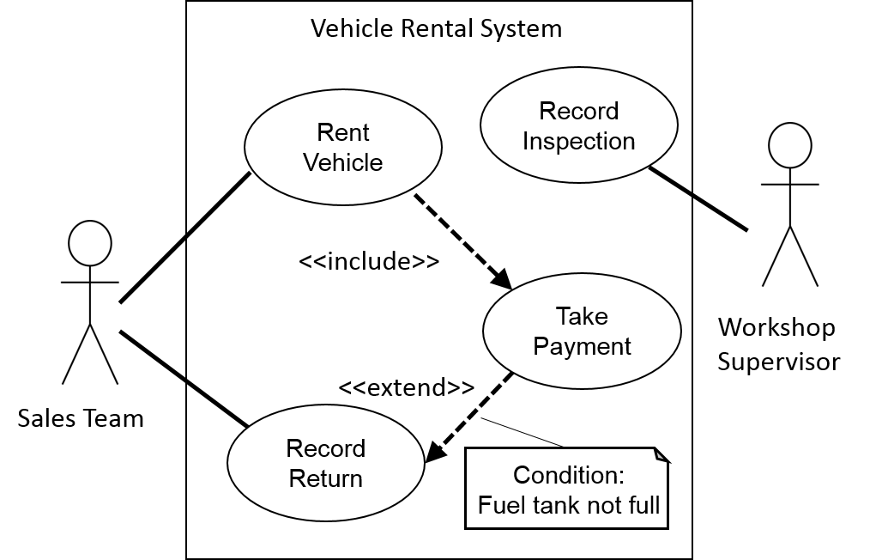**<<extend>>** is used where, under certain, specified conditions, some additional processing is required, exceptional or infrequent things.

Figure 26: Example Use Case Diagram showing <<include>> and <<extend>>

12.2 Modelling System Data

Entity Relationship Diagrams (ERD)

These diagrams are used to identify the data structures required within any organisation and are generally created and maintained for a whole organisation. The purpose of the diagrams is to identify the data that is of importance to an organisation, to record the details of where the data is held and the relationship between one set of data and another.

They are usually associated with database design.

The terminology used is:

* An **Entity** is something of interest to the organisation that the business needs to hold details about. Such as:
  + Something **physical –** an order, a customer a supplier
  + Something **conceptual –** a booking or an appointment
  + Something **active** **–** a meeting or a course
* When drawing an Entity relationship diagram the entities are represented as rectangles
* Hidden within an entity are the **attributes,** the bits of data that are held within that entity, such as an order date; a customer name; a supplier address.
* Entities should be related to other entities by certain business rules and these are represented by lines connecting entities. These lines are known as **relationships** and the extent to which the entities are related is also included. The relationship can be:

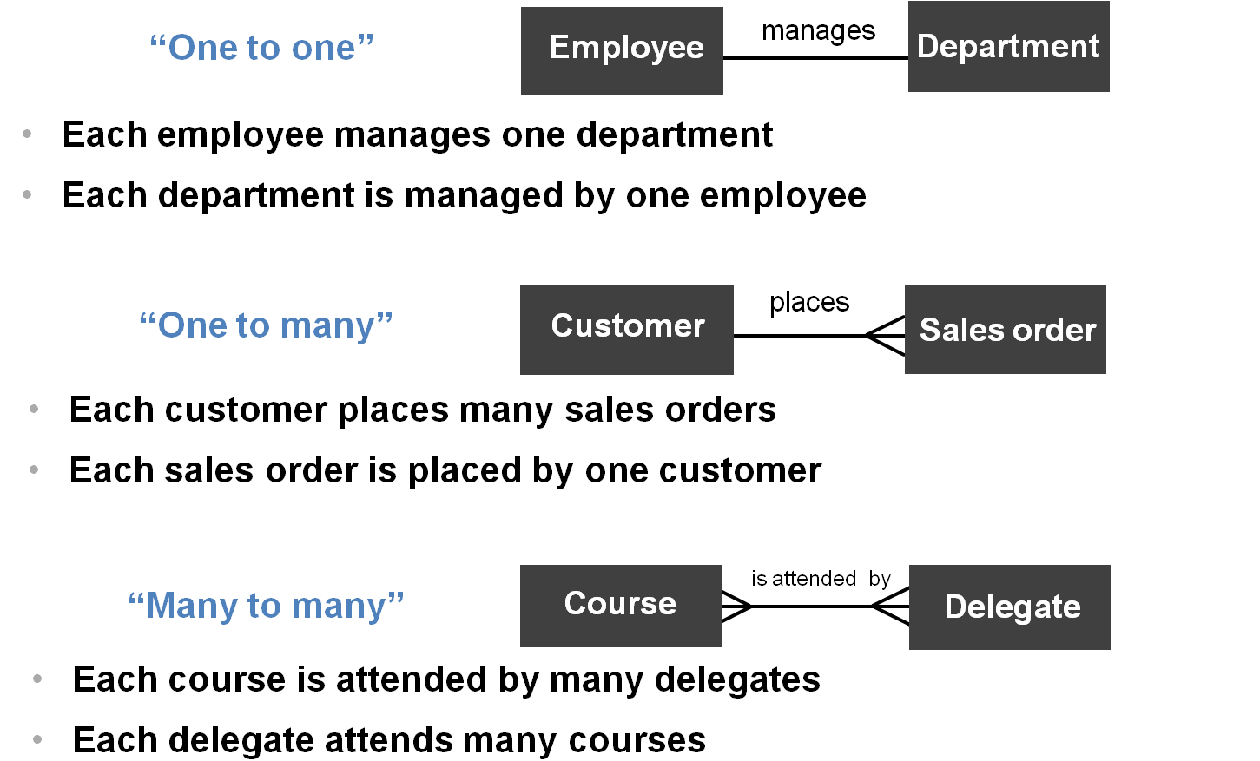

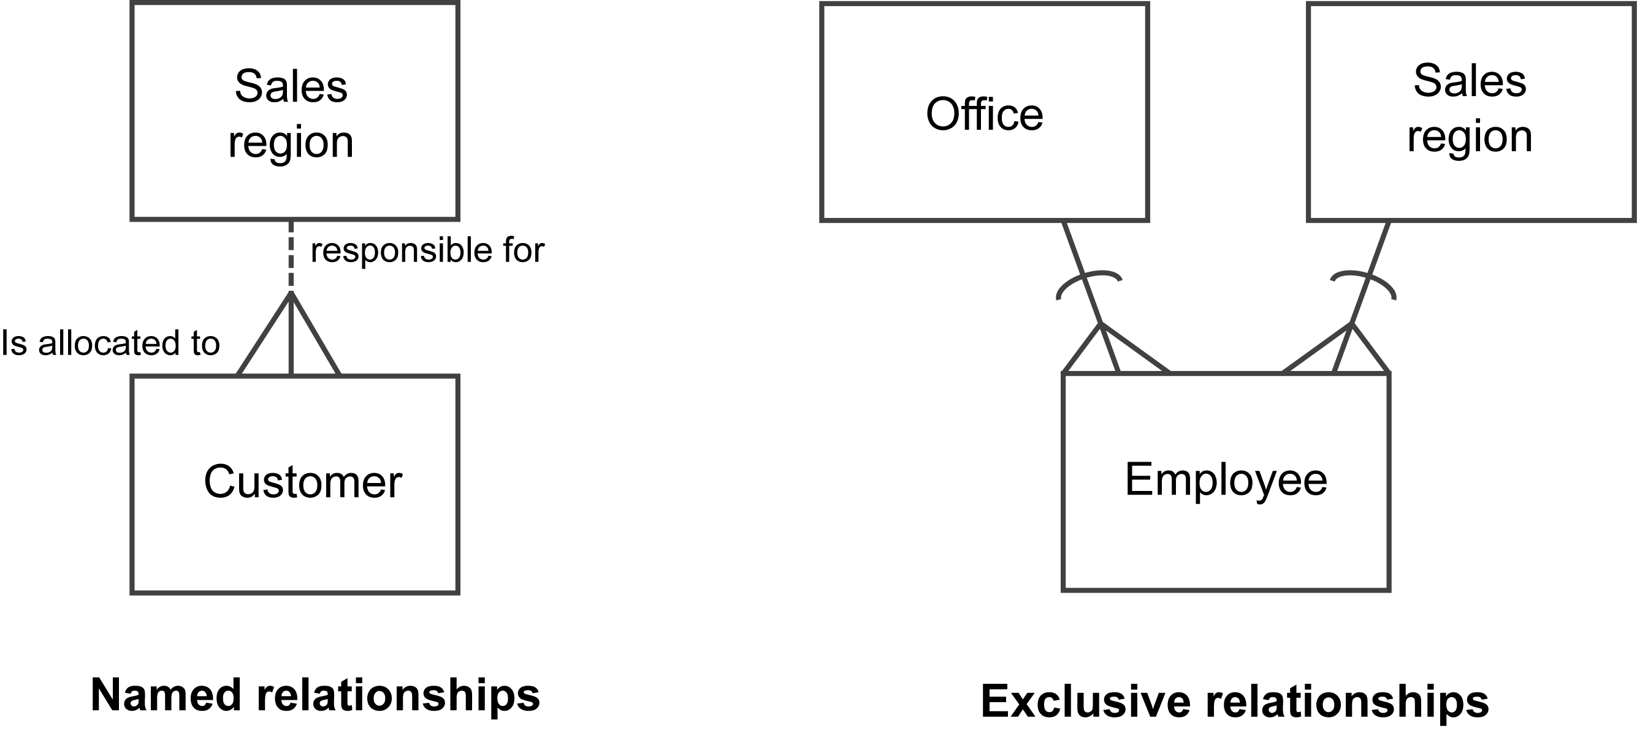  
  
  
  
Relationships can also be named or shown as exclusive:

Class Models

Class models are used in the UML to represent the data connections in a similar way to the Entity Relationship Diagrams, there are notational differences as you would expect, but there are also interpretation and usage differences to be understood too.

|  |  |
| --- | --- |
| **Entity Relationship Diagram** | **Class Model** |
| Entity | Class |
| Occurrence | Object |
| Attribute | Attribute |
| Relationship | Association |
| n/a | Operation |

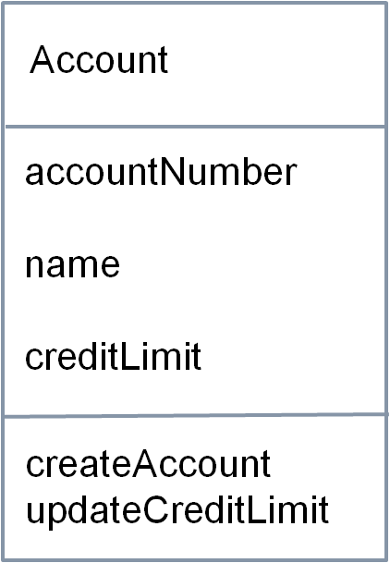A **class** will contain many **objects,** andeach object has a number of **attributes.**

**Class**

**Attributes**

**Operations**

In addition, a class diagram shows for each class what the **operations** are that can be performed on this class; these are the **use cases** identified in the function model.

As each use case will mention the data attributes that it requires to perform its functions, within the UML, the data attributes are said to be **encapsulated** within the use case.

This is a key feature of the Object Oriented approach that uses the UML. Fortunately, in this syllabus you are not expected to know any more about OO than that.

As with the ERD, the association lines show the connections between classes but here, the line indicates that classes communicate via messages sent along the lines.

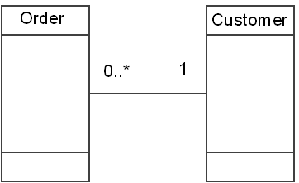Multiplicity is also handled slightly differently on these diagrams. Where we had 'crows feet' to indicate ‘many’ on an ERD, here we have the following symbols:

* **1..\*** is 1 to many
* **0..\*** is 0 to many
* **1..n** indicates that you can use a specific number
* Both ends of an association will use the symbols

Class models have a couple of special diagramming mechanisms:

* **Generalisation and inheritance** is used to indicate where shared data is identified and separated into an additional class. Each subclass is said to **inherit** the '**generalisation**' attributes and operations
* **An association class** is used to resolve 'many to many' associations, which, as mentioned in the ERD section, are not acceptable at the design stage

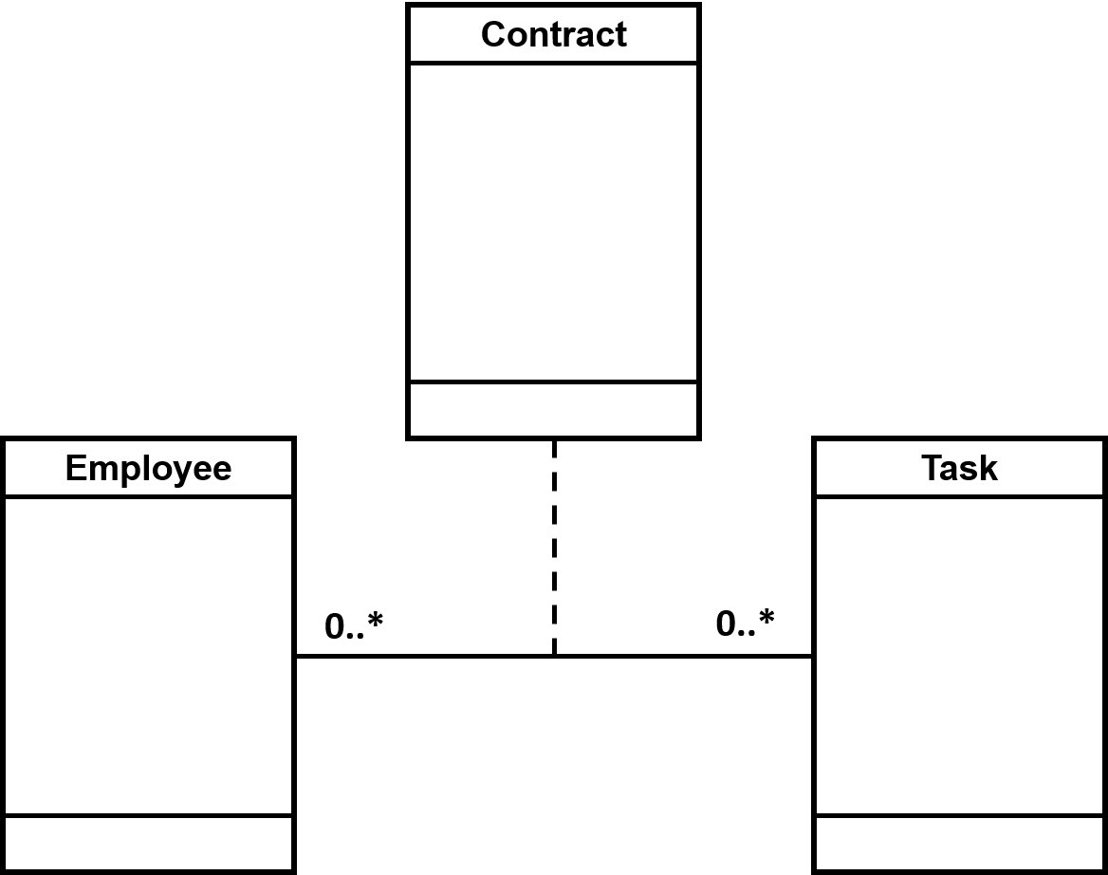Association Classes

Created to resolve many to many multiplicities.

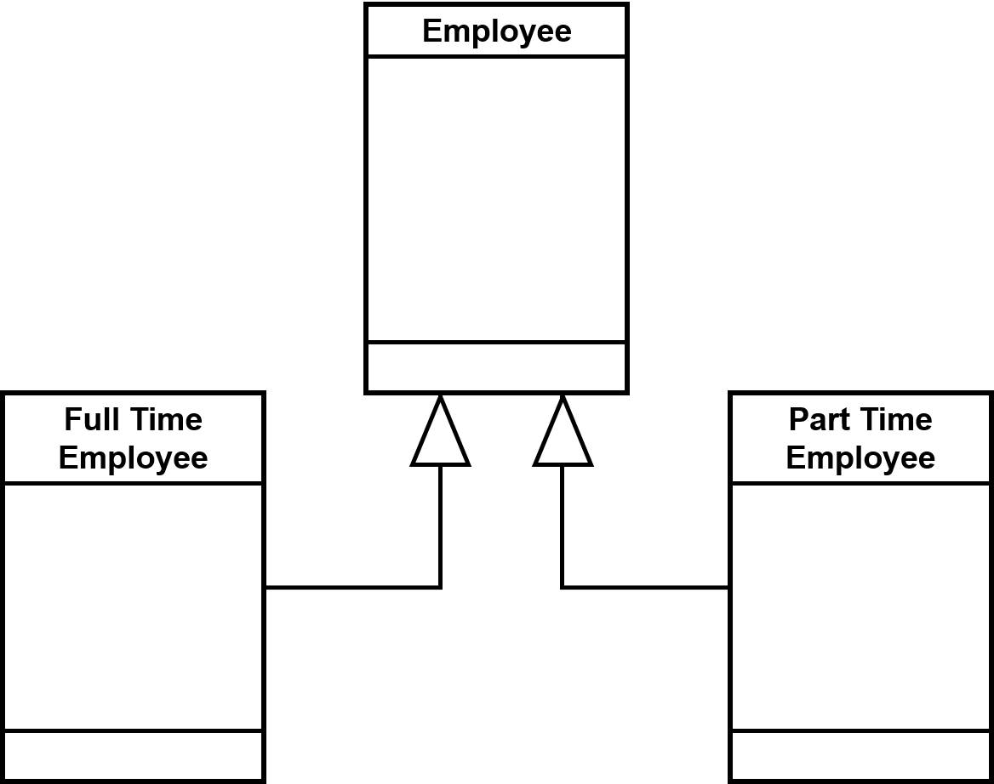Generalisation

Used to show where attributes are shared in more than one class.

Chapter 13. Delivering the Requirements

13.1 Delivering the Solution

Once the requirements have been defined, attention shifts to how the solution can be implemented. There are a number of factors that drive how requirements will be delivered.

The factors under consideration are covered in the following sections.

13.2 Context

The nature of the organisation, and the project, that will provide the basis for deciding how the solution will be delivered.

* **The nature and underlying philosophy of the organisation,** here we can consider questions such as what type of organisation this is, the nature of the business domain within which it operates and the values and beliefs of the senior managers
* **The business context for the required change,** for example, what the organisation is hoping to achieve in terms of business benefit as a result of this project
* **Constraints on the project**, for example, timescales for delivering the solution, the budget, what resources are to be made available and the standards for the organisation
* **The prioritised needs of the business**, for example, improved public image may be more important than cost savings or vice versa
* **The drivers for the project,** for example, whether this project is based upon a need to comply with new legislation or whether it is concerned to offer additional or enhanced services to customers

13.3 Delivery Lifecycles

The process adopted for developing and implementing the solution.

The business change lifecycle shows the overall process but does not show how the IT solution will be delivered**. The development approaches to IT systems are known as systems development lifecycles (SDLCs).** There are a number of approaches that might be used as these have developed over time.

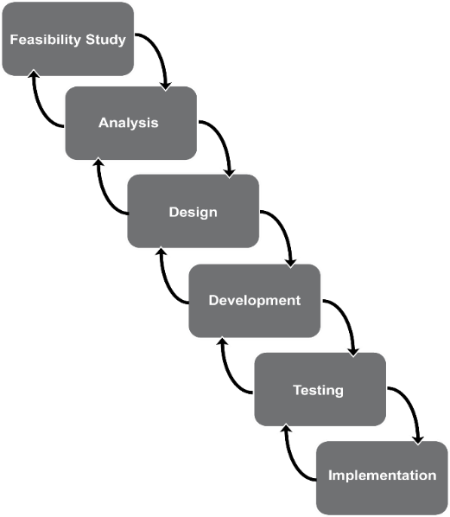The Waterfall Lifecycle

**The Waterfall lifecycle** was the 'original' way in which systems were developed through a series of sequential stages, each performed once the previous stage has completed.

Output from one stage is input to the next, with sign off at the end of each stage.

Waterfall is still used in some places, and often for smaller system changes.

* The principal benefit of this lifecycle is that it enables good project management control
* However, the two major drawbacks are the lack of testing until the solution was complete, and the difficulty in making any changes throughout the lifecycle

Figure 27: The Waterfall Model

The V-Model

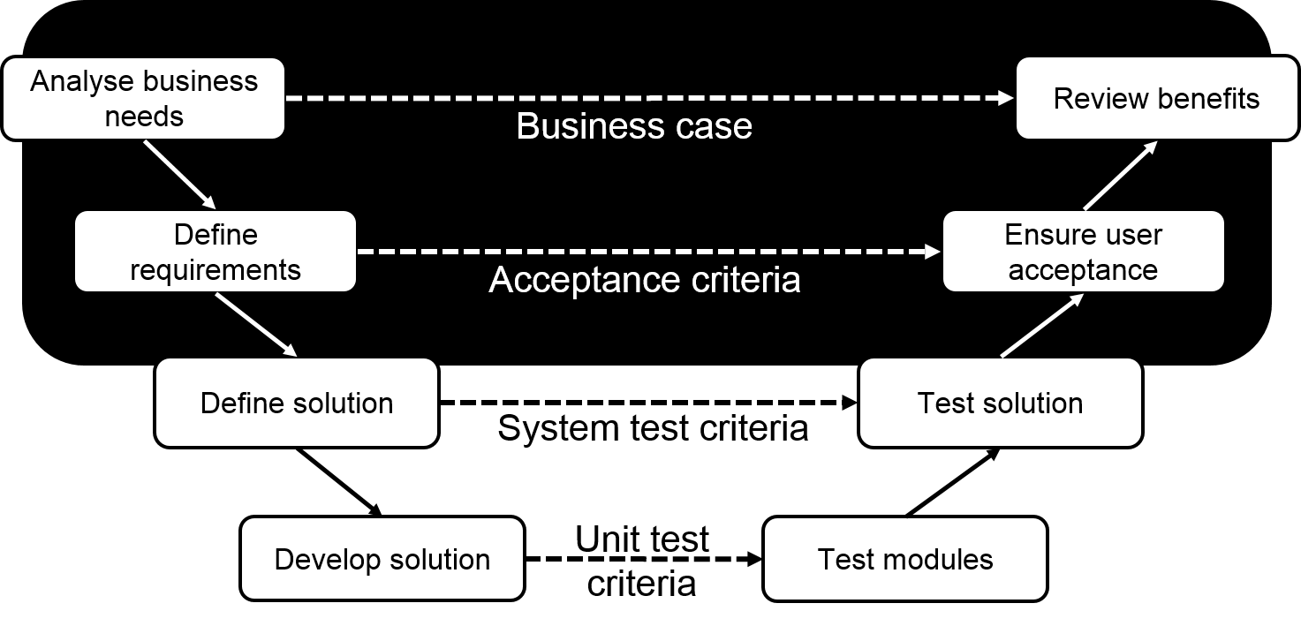

Figure 28: The V-Model

**The V Model SDLC** was introduced to link development activity with testing activity. So all the phases of the waterfall are still performed but each stage also has a level of testing linked to it, this makes for a more robust development lifecycle.

The Incremental Lifecycle

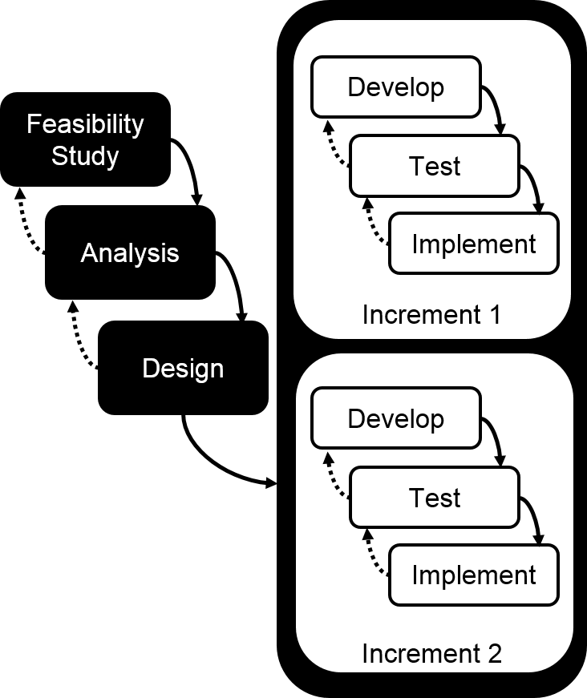In this approach, analysis and design are completed up front.

* Development is divided into discrete phases, which are:
  + Planned
  + Have targeted deliverables
* The product is decomposed into separate components (often referred to as ‘chunked up’)
  + Components are designed, built and tested separately
  + Integration testing (done at the end to pull all components together) can be complex due to the components all being built separately
* The product tends to evolve as each release is completed and it also means that each increment can influence how the next is going to be built

Figure : The Incremental Lifecycle

Iterative Systems Development

Analysis and design is completed up front (similar to Waterfall, V-Model and Incremental)

This approach is governed by fundamental principles:

* Evolutionary
* Empowerment and collaboration
* Fit for purpose
* Test all the time
* Re-factoring
* Incremental delivery
* Prioritisation – eg MoSCoW
* Timeboxing

The Approach

The approach taken by both the IT development team and the business analyst for the business artefacts. It must ensure all the deliverables are produced according to the standards expected by the business.

There are two key issues that will be considered in deciding what approach to use:

* **Delivery of the solution** to the business, will this be a big bang with all areas and all of the solution being implemented at the same time, or a phased implementation?
* **Development of the output**. Here we consider if the requirements are sound or likely to require further definition

Are we going to build the solution in-house or is there the chance to consider a **software package approach?**

**Commercial off the shelf software (COTS)** can be an ideal solution – where one exists, and consideration about the viability of a package would be the subject of a specialist activity within the development project.

Roles

Whatever the approach to developing the outputs is taken, we still need to know who will be doing what and therefore the **roles in delivering requirements** will need to be agreed. Typically, there will be a project or projects within a programme.

Deliverables

The delivery lifecycle and project management approach will both determine the **deliverables** that will be produced.

Techniques

The final area to consider is the different **techniques** that will be used; different lifecycles use different techniques appropriate to that lifecycle.

Finally, it is worth remembering that delivering business change is a team effort requiring different skills from those employed in business as usual, a combined effort will result in the best solution.

Chapter 14. Delivering the Business Solution

14.1 BA Role in the Business Change Lifecycle

**Alignment**: continually checking the strategic direction in a changing environment

**Definition**: planning the human dimension of the change to instil trust as early as possible

**Design**: change isn't just about the solution. The new business processes, IT systems etc. need to be usable

**Implementation**: planning for the change and delivery of that change

**Realisation**: ensuring that the planned change has taken place successfully

14.2 Design Stage

The POPIT™ model is useful to consider all areas of the change:

* People – skills?
* Organisation – structures, measurement and reporting, jobs?
* Process design – implementation?
* Information and Technology – designing, developing and testing the solution?

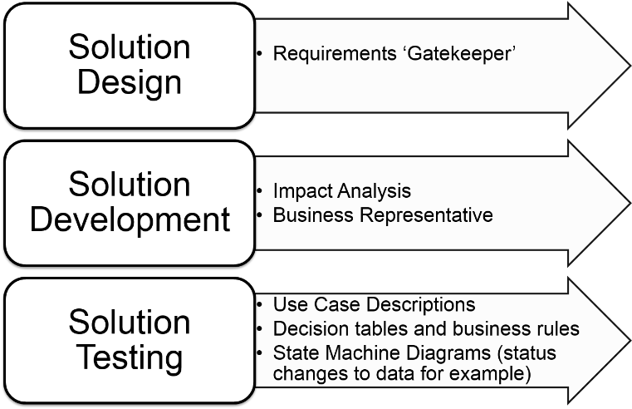Information and Technology

The BA is usually heavily involved in the Design stage and in particular the planning and support of the Information and Technology needs of the business.

During **solution design** the BA is the gatekeeper of the requirements – they must ensure that the requirements are being accurately interpreted and remain true to the needs of the business.

During **development** the BA may be required to assess changes, performing impact analysis and will be the business representative during this time.

During **Testing** the BA may need to create Use Case Descriptions to describe the sequence of tasks needed to test, and the order that these tests occur in. There may also be a need to create or refer to decision tables which can help to understand business rules to ensure that the testing covers all possible combinations.

State Machine diagrams can be used to understand the changes to data during its lifecycle which will be important in planning the sequence of tests and the values required.

14.3 Implementation Stage

People experience **emotions throughout the change process** and these need to be recognised and appropriate action taken by the change team.

Figure 30: The SARAH Model

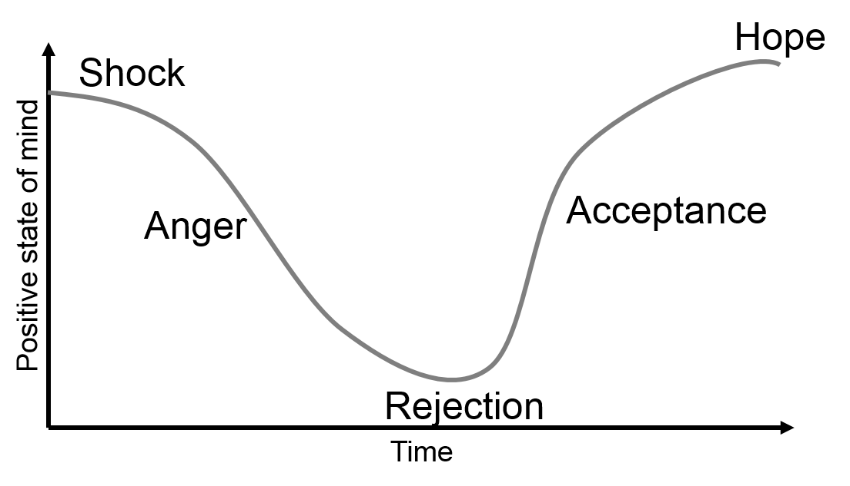

**Self-esteem** will change over **time** and the change team need to have processes in place to identify and support the individuals.

It doesn't seem to matter if the change is an improvement or not, these feelings may occur so the business analyst should be aware of them and use them to develop appropriate communication and support mechanisms.

14.4 Realisation Stage

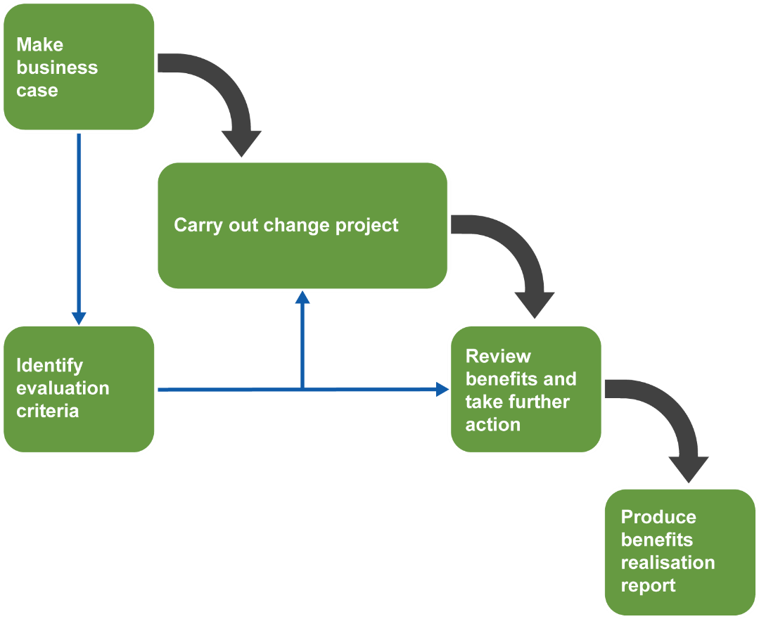When benefits are identified in the business case consideration must be given to how the claimed benefits will be measured. Organisations are increasingly interested in benefits management and realisation. An approach is shown below:

Figure 31: The Benefits Realisation Approach

There are three areas that need attention for an accurate and successful Benefits Realisation stage:

* The Benefits Plan
* Business Case
* Benefits Reviews

Benefits Plan

Context/Vision

* What is the background for the change?
* Provides the business context

Benefits profiles

* Benefit owner – the person who will ensure that the benefit is achieved (this could be through feeding into requirements for reporting so data can be monitored for example)

Benefits dependency network

* Diagram for what needs to be done showing the changes that will enable the change, the business changes required to achieve those and the benefits
* Responsibilities can be included and identified
* Tracking

Business Case

As we have seen this is central to the Business Change Lifecycle. It should be used to:

* Facilitate change controls and impact analysis by checking scope, cost, resources and any constraints or requirements identified for the solution itself (such as restrictions on software or hardware that the business uses)
* Facilitate reviews, both **scheduled** and **unscheduled**

Benefits Reviews

Management processes are needed to ensure that benefits are reviewed in two circumstances:

* **Scheduled reviews –** at each of the decision gates in the project lifecycle
* **Unscheduled review –** whenever a significant event occurs which could impact on the benefits

Consideration must be given to the timescale required for the expected benefits to appear, this could happen months or even years after the project ends.

The final consideration is the **Benefits Realisation report**. This should cover the following criteria:

* Has the change been successful?
* Have we managed time, effort and cost effectively?
* Provide input into future business cases
* Facilitates future selection of projects

1. **Paul, D., Cadle, J. and Yeates, D. (Eds),** (2014) '*Business Analysis'*, 3rd edition, BCS.
2. **Paul, D., Cadle, J. and Yeates, D. (Eds),** (2014) Ch1, p12, '*Business Analysis',* 3rd edition, BCS.